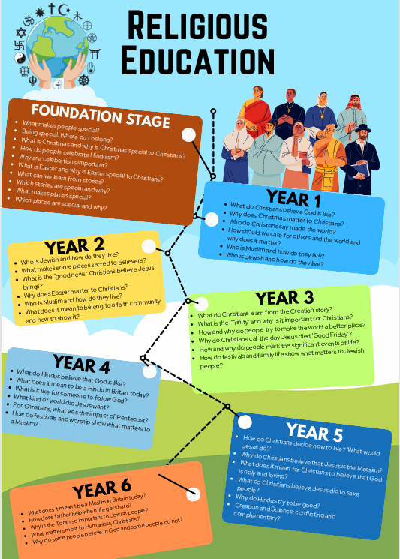
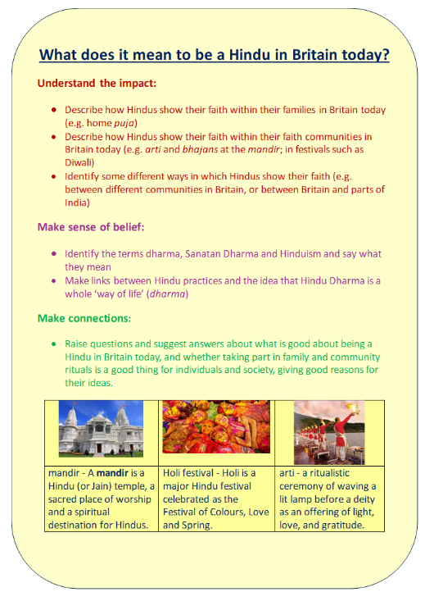
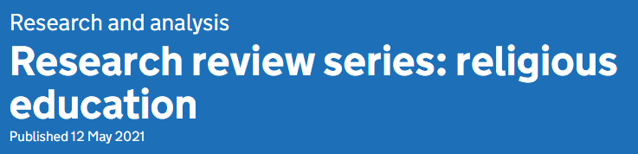
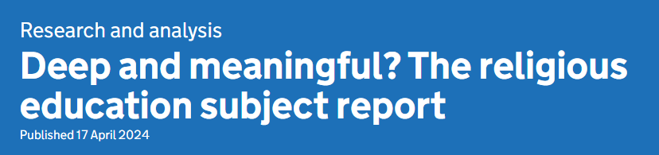
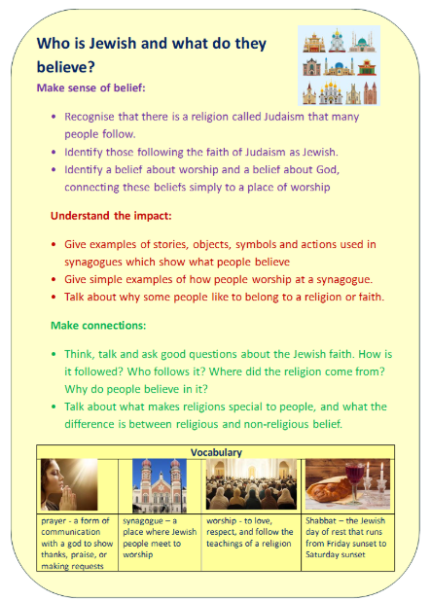
Religious Education
 | Autumn 1 | Autumn 2 | Spring 1  RE Curriculum Map 2026 – 27  Key concepts: creation, gratitude, compassion, victim, sacrifice, sacred, holy, pagan, monotheism, polytheism, immortal, salvation, forgiveness, sin, incarnation, reincarnation, prophet, liberation, obedience, commandment, prayer, worship, wisdom, commitment, faith, belief, celebration, spiritual, moral, social, cultural | Spring 2 | Summer 1 | Summer 2
Nursery | What makes people special?  Festivals: Harvest festival, Diwali  - Begin to make sense of their own life story and family’s history.  - Continue developing positive attitudes about the differences between people.  - Develop their sense of responsibility and membership of a community.  Children begin to learn through stories and talking:  - What makes me special.  - What makes others special to us.  - We are all special in different ways.  - Ways we can help others.  - Why it is important to help others.  - Why we have rules. | What is Christmas?  - Begin to make sense of their own life story and family’s history.  - Continue developing positive attitudes about the differences between people.  - Begin to understand how others might be feeling.  Children begin to learn through stories and talking:  - To think about the likes and feelings of others.  - When and why we give presents.  - Showing gratitude- thank you.  - The Christmas story.  - Why Christians believe Jesus was a special baby.  - Christian families celebrate Christmas.  - All families have celebrations that may be different or similar. | How do people celebrate  Hinduism?  Festivals: Chinese New Year, Holi  - Continue developing positive attitudes about the differences between people.  - Know that there are different countries in the world and talk about the differences they have experienced or seen in photos.  Children begin to learn through stories and talking:  - Different people or communities celebrate different festivals.  - Celebrations may be different but they have elements in common such as new clothes, special food, ‘giving’ presents, special music and dancing. | What is Easter?  - Begin to make sense of their own life story and family’s history.  - Continue developing positive attitudes about the differences between people.  - Develop their sense of responsibility and membership of a community.  Children begin to learn through stories and talking:  - The signs of Spring  - The Easter story.  - New life – baby animals and adult animals, plants. Life-cycles. | What can we learn from stories?  Christianity, Islam, Hinduism, Sikhism  - Continue developing positive attitudes about the differences between people.  - Life cycles (linking back to Easter for new life)  - Know that there are different countries in the world and talk about the differences they have experienced or seen in photos.  Children begin to learn through stories and talking:  - About perseverance, team work and being a good friend.  - Sikhs believe people should be the best person they can be.  - Muslims believe they should praise Allah for the beautiful world He has created.  - Christians believe that God loves everyone and wants them all to be  safe and to live their lives the way God wants them to. | What makes places special?  Christianity, Islam, Judaism  - Begin to make sense of their own life story and family’s history.  - Continue developing positive attitudes about the differences between people.  - Know that there are different countries in the world and talk about the differences they have experienced or seen in photos.  Children begin to learn through stories and talking:  - Similarities and differences between homes (special to us)  - To think about what we want and we need – warmth, shelter, love…  - What makes a church a special place for Christians?  - What makes a mosque a special place for Muslims?  - What makes a synagogue a special place for Jews?  - To think and talk about questions – Do we all like the same places? Is it OK to like different places?
Vocabulary | Christians, special, Bible, miracle, God, Jesus, rules, Jewish, Moses, belief | gold, frankincense and myrrh, precious, gratitude, belief | Giving, celebrate, new year, resolutions, Hindu, festival, belief | Spring, changes, new life, forgiveness | Persevere, encourage, create, Allah, praise, sharing, co-operate, care for, love, god. | Same, similar, different, church, mosque, synagogue
Addressing misconceptions | We all have the same experiences and feel the same way about them. Share what we and our families do and how we feel. | Christmas is about receiving presents. Introduce and revisit the nativity story over the half term to begin to understand the importance of thinking of others. | In our nursery community, we all celebrate the same festivals. Refer to similarities and highlight what is special when we learn about a different faith or culture. | Easter is about chocolate eggs. Refer to new life and the Easter story. | Understanding the take a meaning from a story – not a literal comprehension | It doesn’t have to be richly decorated
Assessment | Observations during activities, and classroom discussions | Observations during activities, and classroom discussions | Observations during activities, and classroom discussions | Observations during activities, and classroom discussions | Observations during activities, and classroom discussions | Observations during activities, and classroom discussions
Key concepts | Belief, morals | Incarnation, belief | Belief, morals | Salvation | Belief, Moral | Belief, morals
Links to British Values | Mutual tolerance  Respectful attitudes  Rule of Law | Mutual tolerance  Respectful attitudes | Mutual tolerance  Respectful attitudes | Mutual tolerance  Respectful attitudes | Mutual tolerance  Respectful attitudes | Mutual tolerance  Respectful attitudes  Democracy
Reception | Being special: where do I belong?  - Shows interest in the lives of people who are familiar to them.  - Remembers and talks about significant events in their own experience.  - Harvest Festival  - Diwali – festival of light | Why is Christmas special to Christians?  - Recognises and describes special times or events for family or friends.  - Introduce the Christmas story and advent.  - Reception Christmas concert. | Why are celebrations important?  - Recognises and describes special times or events for family or friends.  - Shows interest in different occupations and ways of life.  - Knows some of the things that make them unique, and can talk about some of the similarities and differences in relation to friends and family. | Why is Easter special to Christians?  - Children talk about past and present events in their own lives and in the lives of family members.  - Recognises and describes special times or events for family or friends. | Which stories are special and why?  - They know about similarities and differences between themselves and others, and among families, communities and traditions.  - Life cycles (linking back to Easter for new life) | Which places are special and why?  - Help children and parents to see the ways in which their cultures and beliefs are similar, sharing and discussing practices, resources, celebrations and experiences.
Vocabulary | belief, celebration, God, Jesus, life, special, role model, Christianity, Judaism, Moses, ten commandments | belief, celebration, gratitude, moral, God, Jesus, life, new beginnings, present, being thankful, good news, shepherds, nativity | New year, Hinduism, celebration, Lunar New Year, Diwali, Persian, Iran, Holi, | Spring, new beginnings/life, Lent, Easter, Christianity, Eid, Ramadan, Jesus, God, resurrection, | Christianity, Islam, Hinduism, Sikhism, fable, moral, Muslim, Allah, Christian, | Christianity, Islam, Judaism, special place, church, mosque, baptism, wedding, christening, Muslim, Allah, synagogue, Jews, Kippah, uniform
Addressing misconceptions | Not everyone is the same | Everyone celebrates Christmas. | We all celebrate the same festivals – understand that different beliefs have different celebrations. | Easter is about chocolate eggs | They must believe these stories | All temples, churches etc are the same
Discover RE | What makes people special? | What is Christmas? | How do people celebrate? | What is Easter? | What can we learn from stories? | What makes places special?
Assessment | Observations during activities, and classroom discussions
Key concepts | Jesus is God’s son | Incarnation | Gratitude  Worship | Salvation  Reincarnation | Belief  Morals | Worship  Cultural
Links to British Values | Mutual tolerance  Respectful attitudes  Rules of Law | Mutual tolerance  Respectful attitudes | Mutual tolerance  Respectful attitudes | Mutual tolerance  Respectful attitudes | Mutual tolerance  Respectful attitudes  Democracy | Mutual tolerance  Respectful attitudes
Year 1 | What do Christians believe God is like?  - Children will identify what a parable is.  - They will learn to tell the story of the Lost Son from the Bible and recognise that Christians see God as a forgiving Father.  - Children will learn how Christians put their beliefs into practice in worship. | Why does Christmas matter to Christians?  - Children will learn about why Christmas is so important to the Christian faith.  - They will learn to give a clear, simple account of the story of Jesus’ birth and will gain an understanding of why Jesus is important for Christians.  - Children will think about the ways in which Christians use the story of the Nativity to guide their beliefs and actions at Christmas. | Who do Christians say made the world?  - Children will explore the idea of ‘creation’, an idea that many people (Jews, Christians and Muslims) believe in.  - They will learn the story of Genesis and recognise that the ‘Creation’ is the beginning of the ‘big story’ of the Bible.  - They will think about what the story tells Christians about God, creation and the world.? | How should we care for others and the world and why does it matter?  - Children will learn about why Christians and Jews, and other religions might look after the natural world and give examples of how Christians and Jews show care for the Earth.  - Children will be able to give good reasons why everyone (religious and non-religious) should care for others and look after the natural world. | Who is Muslim and how do they live?  - Children will learn that Muslims believe in Allah as the one true God.  - They will learn about the Shahadah.  - They will learn the 99 names for God. | Who is Jewish and how do they live?  - Children will learn about Jewish celebrations, prayers and special objects. They will learn about Jewish beliefs of God.
Vocabulary | God, Christians, bible, forgiving, beliefs | Celebration, bible, God, angels, prayer, Christians | Creation, God, Christians, bible, beliefs | World, care, looking after | God, islam, muslims, beliefs, | Jew, Jewish, belief, shabbat, challah,
Addressing misconceptions | Physical descriptions instead of describing personality | Presents! How is he a king but born in a stable? | Science and alternative stories | Not just in UK, in the whole world. “It’s the governments job” | The pillars are real pillars not a metaphor | We don’t have Jewish people in our community.
Discover RE | Does God want Christians to look after the world? | Why do Christians believe God gave Jesus to the world?  What gifts might Christians in my town have given Jesus if he had been born here rather than in Bethlehem? | Does God want Christians to look after the world? | Is it possible to be kind to everyone all of the time? | Does praying at regular intervals help a Muslim in his/ her everyday life? | How special is the relationship Jews have with God?
Assessment | Observations during activities, class work and classroom discussions | School production and discussion | Conscience alley | Role play – acting | Discussion | Quiz
Key concepts | Concept: God/Creation | Incarnation, Saviour, Advent, Jesus’ teachings, giving – care taken as to the choice of gift | Creation Story -environmental issue/recycling/stewardship | faith, belief, creation Good Samaritan, Love your neighbour, Healing the paralysed man | Holy, prayer, worship, faith, belief, spiritual, moral, social, cultural, | Abraham – Covenant – Birth of Isaac, Moses and the 10 commandments, Mezuzah, Shema
Links to British Values | Mutual tolerance  Respectful attitudes | Mutual tolerance  Respectful attitudes | Mutual tolerance  Respectful attitudes | Mutual tolerance  Respectful attitudes  Democracy | Mutual tolerance  Respectful attitudes  Democracy | Mutual tolerance  Respectful attitudes  Democracy
Year 2 | Who is Jewish and how do they live?  - Find out what many Jewish people do in the home on Shabbat, including preparation for Shabbat, candles, blessing the children, wine, challah  - bread, family meal, rest.  - Explore how some Jewish people call it the ‘day of delight’, and celebrate God’s creation (God rested on the seventh day).  - Look at some stories from the Jewish Bible (Tenakh) which teach about God looking after his people (e.g. the call of Samuel (1 Samuel 3);David and Goliath (1 Samuel 17)). | What makes some places sacred to believers?  - Where do Christians, Muslims and Jews worship? What objects do they use during worship? What makes some places special to believers?  - Special places for people of faith and non-religious individuals. | What is the “good news” Christians believe Jesus brings?  - Think, talk and ask questions about whether Jesus’ ‘good news’ is only good news for Christians, or if there are things for anyone to learn about how to live, giving a good reason for their ideas. | Why does Easter matter to Christians?  - The Easter story.  - Recognise what Salvation and Incarnation is and how it links to Easter.  - Is Easter only relevant to Christians? | Who is Muslim and how do they live?  - Who are Muslims and how do they live?  - Give examples of how Muslims use stories about the Prophet to guide their beliefs and actions (e.g. care for creation, fast in  - Ramadan)  - Think about examples of how Muslims put their beliefs about prayer into action.  - Think, talk about and ask questions about Muslim beliefs and ways of living | What does it mean to belong to a faith community and how to show it?  - Talk about stories of people who belong to groups. Find out about groups to which pupils belong, including their families and school, what they enjoy about them and why they are important to them.  - Find out about some symbols of ‘belonging’ used in Christianity and at least one other religion, and what they mean (Christians: e.g. baptismal  - candles, christening clothes, crosses as badges or necklaces, fish/ichthus badges,  - Muslims: e.g. an example of calligraphy, a picture of the Ka’aba, a taqiyah (prayer cap);  - Jews: e.g. a mezuzah, a menorah, a Kiddush cup, challah bread, a kippah), symbols of belonging in pupils’ own lives and experience.
Vocabulary | Shabbat, challah, delight, tenakh | Prayer, synagogue, mosque, worship, holy, sacred | disciple, belief, diversity | crucifixion, salvation, incarnation | prophet, prayer, Ramadan | spiritual, moral, social, cultural, menorah, baptism, christening, marriage
Addressing misconceptions | If you celebrate the shabbat, you are Jewish | Anywhere could be sacred | That Jesus came back to life. | Jesus came back to life | All Muslims are the same | There is no flexibility in the rules – like school
Discovery RE | How special is the relationship Jews have with God? Abraham – Covenant – Birth of Isaac, Moses and the 10 commandments, Mezuzah, Shema | Does going to a mosque give Muslims a sense of belonging?  Mosque, washing, prayer in a mosque | Was it always easy for Jesus to show friendship? Concept: Incarnation Zacchaeus -- Jesus stills the storm Lazarus - friendship Is it possible to be kind to everyone all of the time? Good Samaritan, Love your neighbour, Healing the paralysed man | Why do Christians believe God gave Jesus to the world? Concept: Incarnation Saviour, Advent, Jesus’ teachings, What gifts might Christians in my town have given Jesus if he had been born here rather than in Bethlehem? Concept: Incarnation Giving – care taken as to the choice of gift | Does praying at regular intervals help a Muslim in his/ her everyday life? Prayer, commitment to Allah | Does completing Hajj make a person a better Muslim?  What is the best way for a Jew to show commitment to God?  Pilgrimage – Hajj – Makkah – significance – 5 pillars  Bar/Bat Mitzvah - Mitzvah day Tu B’Shevat (tree)
Assessment | Observations during activities, class work and classroom discussions | Class discussion and questioning | Discussion | Quiz | Observations during activities, class work and classroom discussions | Observations during activities, class work and classroom discussions
Key concepts | wisdom, faith, belief, holy, spiritual, moral, social, cultural | faith, belief, holy, spiritual, | Faith, belief, holy, spiritual, moral, social, cultural | creation, holy, spiritual | wisdom, faith, belief, holy, spiritual, moral, social, cultural | Forgiveness, wisdom, faith, belief, holy, spiritual, moral, social, cultural
Links to British Values | Mutual tolerance  Respectful attitudes | Mutual tolerance  Respectful attitudes | Mutual tolerance  Respectful attitudes | Mutual tolerance  Respectful attitudes | Mutual tolerance  Respectful attitudes  The rule of law | Mutual tolerance  Respectful attitudes  Democracy
trips |  |  |  |  | Places of worship walk to review the different styles of churches, mosques and temples in the local area.
Year 3 | What do Christians learn from the Creation story?  - Children will be able to place the concepts of God and creation on a timeline of the Bible’s ‘big story’.  - To look at Genesis 1 to understand what Christians believe about God and creation.  - Recognise that the story of ‘the Fall’ in Genesis 3 gives Christians an explanation of why things go wrong in the world. | What is the ‘Trinity’ and why is it important for Christians?  - To explore the symbolism of the baptism ceremony  - To look at ways in which the trinity is used in worship.  - Children will understand what a ‘Gospel’ is and learn some of the stories it contains | How and why do people try to make the world a better place? Christians, Muslims, non-religious  - To identify why the world is not always a good place and make links across religions and why people try and make the world better.  - To research and describe individuals and organisations that work to help others.  - Children will express their own ideas about the best way to make the world a better place, giving reasons for their views and making links with religious ideas studied | Why do Christians call the day Jesus died ‘Good Friday’? Easter and Holy Week  - To look at the Holy Week for Christians and what events will take place.  - To learn and understand what the word ‘salvation’ means to Christians.  - To reflect upon how Easter is celebrated in our community.  - To raise questions about why Christians call the day Jesus died ‘Good Friday’ and give reasons for their answers. | How and why do people mark the significant events of life? Christians, Hindus, Muslims, non-religious  - To describe what happens in ceremonies of commitment and say what these rituals mean.  - To identify some differences in how people celebrate commitment.  - To compare and contrast how two different faiths mark these celebrations | How do festivals and family life show what matters to Jewish people?  - To identify some Jewish beliefs about God, sin and forgiveness and describe what they mean  - To describe how Jews show their belief through worship in festivals both at home and in wider community
Vocabulary | Creation, worship, stewardship, caretaker, sin, relationship | Trinity, symbol, baptism, gospel, church, hymn, bible | Muslim, Islam, Christians, religion, organisations, environment, elderly, kindness | Lent, Easter, good Friday, salvation, community, betrayal, celebration, temptation | Ceremonies, commitment, celebrations | Hanukkah, Bar/Bat Mitzvah, repentance, deliverance, Yom Kippur, justice
Addressing misconceptions | Only the Earth was created, not the whole universe.  The story is only for Christians.  It is scientifically proven. | The holy trinity – how can three people be one? | Not all religions look to make the world a better place | Jesus comes back to life | All people celebrate like my family. Non-religious people don’t have ceremonies.  Myth and ritual were created by people who knew less than we do. We live in a more rational age. | These are the only important things to Jewish people  Sacred texts are magical books that show us how to live.
Discovery RE | Do people need to go to church to show they are Christians?  Church, baptism, Eucharist, worship, daily life, prayer – stewardship. | Does belief in the trinity help Christians make better sense of God as a whole?  Trinity, bible, church, hymns, creeds, gospels | Thematic  Could Jesus heal people? Were these miracles or is there some other explanation?  Jesus and the blind man – The paralysed man - miracles | What is ‘good’ about Good Friday?  The Last Supper, crucifixion, forgiveness. | Thematic  Would visiting the River Ganges feel special to a non-Hindu?  River Ganges, pilgrimage, funeral customs, Varanasi | God/torah/people/the land  How important is it for Jewish people to do what god asks them to do?  Kashrut, kosher, Passover, seder meal
Assessment | Teacher judgement – looking over the past few lessons and judging whether than have met the LO for each lesson, | Week 4 review in Spring 1. Recap session. | Discussion and debate.  Answer the overarching question that is on the whiteboard. Discuss who? How? What would you do? | Write a small paragraph answering the main question using their knowledge from the past few weeks of the topic. | Small quiz on paper focussing on drawing comparisons between the religions. | Large mind map on the whiteboard answering and discussing the 3 bullet points above
Key concepts | Creation, monotheism, worship, belief, commitment, wisdom | Ceremony, worship, celebration, holy, monotheism, belief | Compassion, gratitude, commitment, celebration, incarnation | Celebration, salvation | Faith, celebration, spiritual, social, cultural | Celebration, worship, commitment, faith
Links to British Values | Mutual tolerance  Respectful attitudes | Mutual tolerance  Respectful attitudes | Mutual tolerance  Respectful attitudes  Individual liberty  Democracy | Mutual tolerance  Respectful attitudes | Mutual tolerance  Respectful attitudes  The rule of law  Democracy | Mutual tolerance  Respectful attitudes
Trips |  |  |  |  | Visit a mosque to learn about key ceremonies that take place there.
Year 4 | What do Hindus believe that God is like?  - Identify some Hindu deities and say how they help Hindus describe God.  - Make simple links about God and how Hindus live.  - Raise questions and suggest answers about whether it is good to think about the cycle to create/ preserve/ destroy in the world today. | What does it mean to be a Hindu in Britain today?  - Describe how Hindus show their faith within their families in Britain today.  - Identify the terms dharma, Sanatan Dharma and Hinduism and say what they mean.  - Raise questions and suggest answers about what is good about being a Hindu in Britain today and whether taking part in family or community rituals is a good thing for individuals and society. | What is it like for someone to follow God?  - To make clear links between the story of Noah and the idea of covenant.  - Make simple links between promises in the story of Noah and the promises that Christians make at a wedding ceremony.  - Make links between the story of Noah and how we live in school and the wider world. | What kind of world did Jesus want?  - Identify Jesus healing the leper and Noah’s Ark, that come from a Gospel, which tells a story of the life and teaching of Jesus.  - Make links between the calling of the first disciples and how Christians today try ad follow Jesus.  - Give examples of how Christians try to show love for all.  - Make links between the importance of love in the Bible stories studied and life the world today, giving a good reason for their ideas. | For Christians, what was the impact of Pentecost?  - Make clear links between the story of the Pentecost and Christian beliefs about the ‘kingdom of God’ on Earth.  - Describe how Christians show their beliefs about the Holy Spirit in worship.  - Make links between the kingdom of God in the Bible and what people believe about following God today. | How do festivals and worship show what matters to a Muslim?  - Identify some beliefs about God in Islam.  - Give examples of ibadah in Islam and describe what they involve.  - Make links between the Muslim idea of living in harmony with the Creator and the need for all people to live in harmony with each other in the world today, giving good reasons for their ideas.
Vocabulary | Hindu, deities, reincarnation, atman, karma, samsara, Brahman, puja, Divali | Mandir, Holi festival, Arti, puja, holy texts | Christianity, the Bible, Old Testament, New Testament, covenant, promises, Gospels | New Testament, Gospels, church, morals, Samaritans, charity, Jews, disciples | New Testament, Gospels, church, morals, Pentecost, disciples | Islam, mosque, Ramadan, pillars of Islam, Eid, Qur’an,
Addressing misconceptions | Guru Nanak is the god | Namaste, yoga instead of greeting | All experiences are the same | Jesus only wants people to be Christians | The holy spirit is a ghost | Sacred texts are magical books.
Discovery RE | What do Hindus believe God is like (Brahman/atman)  How can Brahman be everywhere and in everything?  Braham, deities, Ganesha, Trimurti | What does it mean to be Hindu in Britain today? (Dharma)  Would celebrating Divali at home and in the community bring a feeling of belonging to a Hindu child?  Story of Rama and Sita, Divali, Lakshmi, temple | What is it like for someone to follow God?  How special is the relationship Jews / Christians have with God?  Covenant, Abraham, Isaac, Moses, Ten Commandments, Synagogue, Torah, New Tamid, Mezuzah, Shema | What kind of world did Jesus want?  Is forgiveness always possible for Christians?  Concept: Salvation  The Last Supper, Forgiveness, Jesus’ teachings on enemies, anger, revenge | For Christians, what was the impact of Pentecost?  What is the best way for a Christian to show commitment to God?  Love your neighbour, Faith in action, Christian charities, Mother Teresa, Martin Luther King, prayer, Communion, church | How do festivals and worship show what matters to a Muslim?  How special is Allah to Muslims? How does the Qur’an influence Muslims today?  Respect – 99 names of Allah focus on 10 of these – Qur’an  Care of the Qur’an – Importance to Muslims – Stewardship – Muhammad’s last speech
Assessment | Teacher judgement – looking over the past few lessons and judging whether than have met the LO for each lesson, | Week 4 review in Spring 1. Recap session. | Teacher judgement – looking over the past few lessons and judging whether than have met the LO for each lesson. | Final piece of work – what type of world would you like? How does this compare with the world Jesus wanted? | Big question – Why is the Pentecost and Easter important to Christians? | Big question – How is Islam different and similar to the other religions we have studied this year?
Key concepts | Holy, reincarnation, worship, faith, belief, spiritual, cultural, celebration, polytheism | Holy, reincarnation, worship, faith, belief, spiritual, cultural, celebration, polytheism | Holy, monotheism, salvation, forgiveness, commandment, worship, wisdom, faith, moral, sin | Holy, compassion, monotheism, salvation, forgiveness, worship, faith, moral, belief, commitment, prayer | Compassion, sacrifice, scared, holy, monotheism, salvation, forgiveness, sin, prayer, worship, faith, belief, spiritual | Sacrifice, scared, monotheism, prophet, obedience, prayer, worship, commitment, faith, belief, celebration, cultural
Links to British Values | Mutual tolerance, respectful attitudes, individual liberty | Mutual tolerance, respectful attitudes, individual liberty | Mutual tolerance, respectful attitudes, individual liberty | Mutual tolerance, respectful attitudes, individual liberty | Mutual tolerance, respectful attitudes | Mutual tolerance, respectful attitudes, individual liberty
Year 5 | How do Christians decide how to live? ‘What would Jesus do?’  - Understand how parables, miracles and scripture from the bible influence the ways Christians live  - Understand how prayer is used by Christians  - Explore the meaning of the lord’s prayer and how it influences Christian’s live | Why do Christians believe that Jesus is the Messiah?  - Learn how to explain the place of incarnation and Messiah within the ‘big story’ of the bible.  - Identify Gospel and prophecy texts, using technical terms. Explain connections between biblical texts, incarnation and Messiah, using theological terms.  - Show how Christians put their beliefs about Jesus’ incarnation into practice in celebrating Christmas.  - Weigh up how far the idea of Jesus as the Messiah – as Saviour from God – is important in the world today, if it’s true what difference might that make in people’s lives giving good reasons for their answers | What does it mean for Christians to believe that God is holy and loving?  - Identify some different types of biblical texts, using technical terms accurately.  - Explain connections between biblical texts and Christian ideas of God, using biblical terms.  - Make clear connections between Bible texts studied and what Christians believe about God.  - Show how Christians put their beliefs into practice in worship. Weigh up how biblical ideas and teachings about God as holy and loving might make a difference in the world today, developing insights of their own. | What do Christians Believe Jesus did to Save People?  - Explain what Christians mean when they say that Jesus’ death was a sacrifice.  - Make clear connections between the Christian belief in Jesus’ death as a sacrifice and how Christians celebrate the Lord’s Supper/Holy communion/Eucharist.  - Show how Christians put their beliefs into practice in different ways.  - Consider the idea of sacrifice in their own lives | Why do Hindus try to be good?  - Identify and explain Hindu beliefs. Give meanings for the story of the man in the well and explain how it relates to Hindu beliefs about samsara, moksha, etc.  - Make clear connections between Hindu beliefs about dharma, karma, samsara and moksha and ways in which Hindus live. Connect the four Hindu aims of life and the four stages of life with beliefs about dharma, karma, moksha etc.  - Give evidence and examples to show how Hindus put their beliefs into practice in different ways.  - Reflect on and articulate what impact belief in karma and dharma might have on individuals and the world, recognising different points of view. | Creation and Science: conflicting or complementary?  - Identify what type of text some Christians say Genesis 1 is, and its purpose. Talking into account the context, suggest what Genesis 1 might mean, and compare their ideas to ways in which Christians might interpret it.  - Make clear connections between Genesis 1 and Christian belief about God as Creator.  - Show understanding of why many Christians find science and faith go together.  - Weigh up how far the Genesis 1 creation narrative is in conflict or is complementary, with a scientific account, giving good reasons for their views.
Vocabulary | Gospel, parable, interpretation, Christian, Jesus, sermon, beatitudes, blessed, justice, Udayan, miracles, adoration, confession, reconciliation, thanksgiving, supplication, request, sin, temptation, kingdom | Messiah, Israelites, saviour, Babylonians, councillor deliverance, punishment, message, incarnation, saviour, joy, gifts , Second Coming, saviour, world issues, division | divine being, supernatural, holy, sinful, perish, righteous, devotion, perseveres, church, lectern, font, altar, crucifix, confessional, hymns, Beatitudes, Christianity, Humanism | Lent, Holy City, sacrifices, resurrection,  Temptation, Passover, Last Supper, Judas , Pontius Pilate, crucified and resurrected, sacrifice, Jesus, sin, Eucharist, communion, bread, body, blood, martyr, apostle, oracle | Brahma, Vishnu, Shiva, mandir, Atman, Dharma, Samsara, Karma, Moksha, , consequences, reincarnations | Genesis, creation, genre, Genesis, literal, metaphorical, cosmology, Big Bang, evolution, Creation, science, conflict, complement, justify
Addressing misconceptions | Prayers can be used to forgive anything. | A messiah can save himself | If God is loving, bad things shouldn't happen.  God only loves good people | Jesus saved people from drowning or danger like a superhero or stopping/ending a war | All Hindus are good people | You can’t believe in science and RE
Discovery RE | Is forgiveness always possible for Christians?  Concept: Salvation  The Last Supper, Forgiveness, Jesus’  teachings on enemies, anger, revenge, | What is the most significant part of the nativity story for Christians today?  Concept: Incarnation  Christmas symbols, angel, star, gifts, Incarnation, Christingle | What does it mean if Christians believe God is holy and loving?  Does belief in the Trinity help Christians make better sense of God as a whole?  Trinity, Bible, church, hymns, creeds, Gospels | Could Jesus heal people? Were these miracles or is there some other explanation?  Concept: Incarnation  Jesus and the blind man-The paralysed man - Miracles | Good deeds, Rama, re-incarnation, Sadhu | Links could be made to some Discovery RE enquiries like ‘Is the Christmas story true?’ – this examines truth claims
  Do beliefs in Karma, Samsara and Moksha help Hindus lead good lives?
Assessment | Teacher judgement – looking over the past few lessons and judging whether than have met the LO for each lesson, | Teacher judgement – looking over the past few lessons and judging whether than have met the LO for each lesson,  Discussion and debate. | Discussion and debate of overarching question: What does it mean for Christians to believe that God is holy and loving? | Teacher judgement – looking over the past few lessons and judging whether than have met the LO for each lesson, | Discussion and debate.  Answer the overarching question that is Why do Hindus try to be good? | Discussion and debate.  Answer the overarching question that is can science and religion co-exist?
Key concepts | Morality, worship, miracles, prayer, modernism | Worship, divinity, prophecy, scripture, miracles, incarnation | Divinity. Worship. Belief, Humanism | Sacrifice, sin, celebration, communion, martyrdom | Reincarnation, worship, creation, karma, moksha, duty | Creation, critical thinking, traditionalism, modernism, cosmology, science
Links to British Values | Mutual tolerance, Respectful attitudes, Individual liberty, | Mutual tolerance, Respectful attitudes, Individual liberty, | Mutual tolerance, Respectful attitudes, Individual liberty | Mutual tolerance, Democracy, The rule of law, Individual liberty | Mutual tolerance, Respectful attitudes, Individual liberty, | Mutual tolerance, Respectful attitudes, Individual liberty
Trips |  |  |  | Visit to a C of E church.
Year 6 | What does it mean to be a Muslim in Britain today?  - The principle aim is to explore what people believe and what difference it makes to how they live.  - To identify and explain Muslim beliefs about God, the Prophet and the Holy Qur’an.  - To describe ways in which Muslim sources of authority guide Muslim living.  - To make connections between Muslim beliefs and Muslim ways of living in the UK today.  - To give evidence and examples to show how Muslims put their beliefs into practice. | How does faith help when life gets hard?  - For Christians, what kind of king is Jesus? | Why is the Torah so important to Jewish people?  - The principle aim is to explore what people believe and what difference it makes to how they live.  - To identify and explain Jewish beliefs about God.  - To give examples of some texts which say what God is like and explain how Jewish people interpret them.  - To make clear connections between Jewish beliefs about the Torah and how they use and treat it. To give evidence and examples to show how Jewish people put their beliefs into practice in different ways | What matters most to Humanists, Christians?  - The principle aim is to explore what people believe and what difference it makes to how they live.  - To identify and explain beliefs about why people are good and bad (e.g. Christian and Humanist)  - To make links with sources of authority that tell people how to be good  - To suggest reasons why it might be helpful to follow a moral code.  - To make connections between the values studied and their own lives, and their importance in the world today, giving good reasons for their views. | Why do some people believe in God and some people not?  - The principle aim is to explore what people believe and what difference it makes to how they live  - To identify and explain what religious and non-religious people believe  - To give examples of reasons why people do or do not believe in God  - To make connections between belief and behaviour in their own lives  - To make clear connection between what people belief about God and how they respond to challenge in life | Why do some people believe in God and some people not?  - Why do some people believe in God and some people not? Christians, non-religious  - The principle aim is to explore what people believe and what difference it makes to how they live  - To identify and explain what religious and non-religious people believe  - To give examples of reasons why people do or do not believe in God  - To make connections between belief and behaviour in their own lives  - To make clear connection between what people belief about God and how they respond to challenge in life
Vocabulary | 5 pillars – prayer – charity -fasting – Hajj pilgrimage | Actions/consequences, Greater Jihad, Military Jihad, Qur’an, Lesser Jihad/Holy War | Covenant, Abraham, Isaac, Moses, Ten Commandments, Synagogue, Torah, Ner Tamid, Mezuzah, Shema | Love your neighbour, Faith in action, Christian charities, Mother Teresa, Martin Luther King, prayer, Communion, church  Golden Rule, Humanist beliefs and ideas. | Love your neighbour, Faith in action, Christian charities, Mother Teresa, Martin Luther King, prayer, Communion, church  Golden Rule, Humanist beliefs and ideas. | Love your neighbour, Faith in action, Christian charities, Mother Teresa, Martin Luther King, prayer, Communion, church ,Golden Rule, Humanist beliefs and ideas.
Addressing misconceptions | Muslims are not interested in educating girls | Prayer can fix problems | Religious, holy books have been read by all of the followers | All religions and world views are the same | Everyone believes in God, just in different ways  People who don’t believe in God are bad or wrong  Only people who go to church believe in God  If you can’t see God, then God isn’t real | All religions and world views are the same
Discovery RE | What is the best way for a Muslim to show commitment to God? | Does belief in Akhirah (life after death) help Muslims lead good lives? | How special is the relationship Jews have with God? | What is the best way for a Christian to show commitment to God?  How should Humanists lead a good life? | Is anything ever eternal?  (material could be added to this using content from several enquiries and Humanists UK resources) | Is anything ever eternal?  (material could be added to this using content from several enquiries and Humanists UK resources)
Assessment | Teacher judgement – looking over the past few lessons and judging whether than have met the LO for each lesson. | Teacher judgement – looking over the past few lessons and judging whether than have met the LO for each lesson. | Teacher judgement – looking over the past few lessons and judging whether than have met the LO for each lesson | Teacher judgement – looking over the past few lessons and judging whether than have met the LO for each lesson. | Teacher judgement – looking over the past few lessons and judging whether than have met the LO for each lesson. | Teacher judgement – looking over the past few lessons and judging whether than have met the LO for each lesson.
Key concepts | Monotheism, prophet, prayer, worship, faith, belief, sacred, holy | Faith, belief, compassion, social, spiritual, commitment, gratitude, forgiveness, prayer | Monotheism, sacrifice, commandment, prayer, worship, commitment, faith, belief | Gratitude, compassion, forgiveness, prayer, wisdom, commitment, faith, belief, moral, social, cultural | Gratitude, compassion, forgiveness, prayer, wisdom, commitment, faith, belief, spiritual, moral, social, cultural | Gratitude, compassion, forgiveness, prayer, wisdom, commitment, faith, belief, spiritual, moral, social, cultural
Links to British Values | Mutual tolerance, respectful attitudes, individual liberty | Mutual tolerance, respectful attitudes, individual liberty | Mutual tolerance, respectful attitudes, individual liberty | Mutual tolerance, respectful attitudes, individual liberty | Mutual tolerance, respectful attitudes, individual liberty | Mutual tolerance, respectful attitudes, individual liberty
Key concepts: creation, gratitude, compassion, victim, sacrifice, sacred, holy, pagan, monotheism, polytheism, immortal, salvation, forgiveness, sin, incarnation, reincarnation, prophet, liberation, obedience, commandment, prayer, worship, wisdom, commitment, faith, belief, celebration, spiritual, moral, social, cultural

