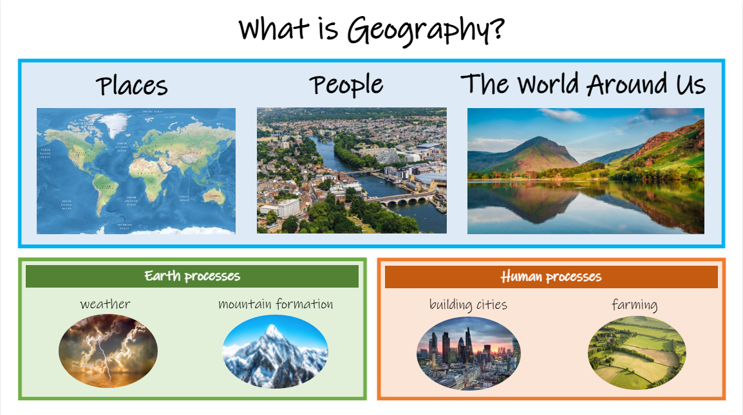


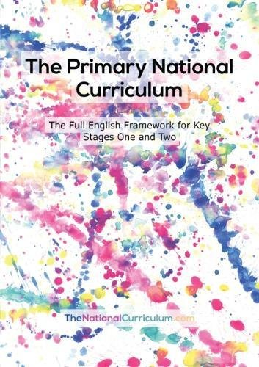

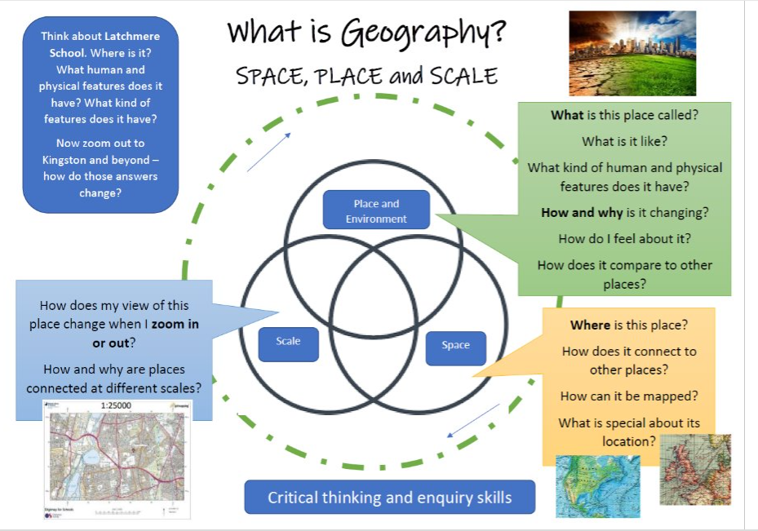

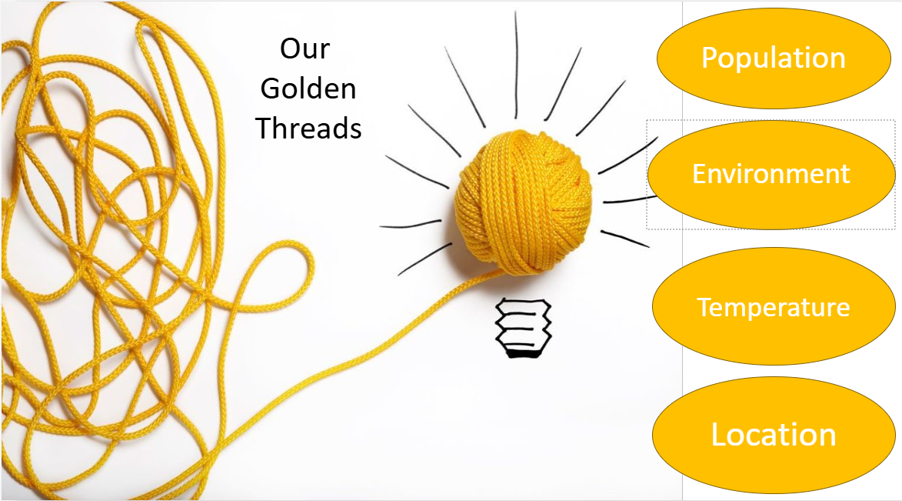

Geography curriculum map 2026 – 2027 - Nursery

 | Autumn |  | Spring |  | Summer
Nursery | Marvellous Me!  - Continue developing positive attitudes about the differences between people. (We belong to a family and a community. How are we the same/different?)  - Know that there are different countries in the world, in relation to their own families. (Class world map) | Let’s Celebrate!  - Continue developing positive attitudes about the differences between people. (How are our celebrations the same/different?)  - Know that there are different countries in the world, in relation to their own families (Linked to festivals).  - Talk about what they see using a wide vocabulary. | Where do I live?  - Comments and asks questions about the place where they live or the natural world. (Weather, homes, Spring walk)  - Talk about what they see using a wide vocabulary. (houses, weather, natural objects)  - Look closely at similarities & differences. (Houses).  - Read traditional stories and map them – The 3 Little Pigs  - To know the name of the road I live in and the postcode. | Animals  - Know that there are different countries in the world and talk about the differences they have experienced or seen in photos (Comparing animal habitats -hot/cold countries).  - Show care and concern for living things and the environment – ongoing.  - Read traditional stories and map them - The Gingerbread Man/We’re Going on an Egg/Bear Hunt.  - Discuss weather | What’s in the Garden?  - Shows care and concern for living things and the environment.  - Comments, asks questions about familiar world.  - Know that there are different countries in the world and talk about the differences they have experienced or seen in photos. | Let’s have an Adventure!  - Know that there are different countries in the world and talk about the differences they have experienced or seen in photos (talk about visiting families or going on holiday in different countries).  - Latchmere Goes Global
Mapping skills and fieldwork | What is in nursery? Where can we find it?  - Familiarising ourselves with our environment, inside and outside.  - Locating areas and resources.  Use maps in pretend play  – car mat  - animals on carpet map  -Examine and discuss natural objects in the physical environment e.g. autumn leaves, twigs, stones, seeds. Take digital photos of a collection of natural objects. | Where is the leisure area? What is there?  -Describe the journey to and from, as we make the journey.  Where is the post box?  Fieldwork – Let’s walk to the post box  - Use ‘Google Earth’ to look at the local area – how we get to the post box.  -Take photos of route. Remember & sequence the landmarks after – zebra crossing, roundabout, park.  -sketch map of route and features -Express feelings about places visited saying what is liked or disliked.  -Sequence photographs to recall features seen on a visit.  Add a key to the map – to understand that a picture or symbol can represent a feature e.g. A tree represents the park. | Where do we live?  -Visit and observe houses on a local walk.  - Name parts of a house and materials brick, glass, wood. Explore and describe materials.  - Talk about similarities/diffs.  -Use ‘Google Earth’ to look at local area and notice school, park, roads, roundabout.  -Describe how we get to the leisure area.  -Draw a simple map of our journey (Spring walk, local walk or leisure area). | Where do animals live?  -Look at Africa and the arctic on a world map with adults  -Find out some of the animals who live in those countries..  - Farm visit  -Describe where objects, people, animals are on maps or using small world resources.  What’s the weather like today?  -Experience different weather conditions and their impact on the environment  -Describe what we see, hear and feel in the sky/outside – clouds, sun, rain, wind | -Draw shapes to represent objects and features – story maps, children’s own maps.  -Create small worlds with different resources, for example, make a garden.  -Talk about distance on our local walk and on walk to the leisure area or around school.  - Children and parents put family photos on our class world map. | -Begin to explore scale through small world play.  Read ‘Journey’ stories – The Bear Hunt and make 3D maps of the stories using small world toys, train tracks and real-life objects.  Create a ‘journey string’ of the ‘Bear Hunt’  Large scale – aerial views.  Look from the top of the climbing frame – what can we see below us?  Look at the school on ‘Google Earth’
Vocabulary | area names, resource names  Where is the creative area, dough table…?  Next to, in the, by the…. | Post box, zebra crossing, roundabout, park | brick, glass, wood, road, street, map,  Directional language – in, out, through, around, along | in front of, behind, next to.  Start to model ‘left’ and ‘right’.  Rainy, sunny, cloudy | a long way, far away, near | holiday, sea, places, hot, cold, transport.
Addressing misconceptions | Resources can go anywhere.  Understanding positional language and responding to it. | There is one way to get to the leisure area. (Use an alternative route once initial route is familiar) | We all live in the same types of homes.  (Talk about how our homes are the ‘same’ and ‘not the same’) | All animals live on a farm.  (Learn farm animal names. Look at pictures of animals and set up small world polar and wild animal habitats) | All homes have gardens. Who has a garden, who lives in a house or flat?  Our families come from the same place.  (Put family pictures on the world map) | We can walk to another country. (Small world play and talk about walking to the park and transport used to travel to far away countries).
Assessment | Children can name and locate some areas and resources.  Children can talk about their family. | Children can talk about some features of their journey – landmarks and what they are for.  How do they know where the park is on the map?  They can talk about a celebration. | Children can talk about some features of their journey – landmarks and what they are for. | Children can talk about the weather they observe.  They name some arctic animals, some African animals and some farm animals | Children can say how a playground park and a garden are the same or different. | They can talk about their experience of going to a different country or about what they have seen.
Key concepts | Human, location | Human, physical, location | Human, physical, location, environment | Human, physical, location, habitat, temperature. | Human, physical, location, habitat, | Human, physical, location, habitat, temperature

Reception | All about me  - Talk about members of their immediate family and community.  - Name and describe people who are familiar to them.  - Recognise some environments that are different from the one in which they live.  - Look at the location of their classroom and features of the school.  - Walk around the EYFS and map the area.  - Chn to learn about where they live, learn their address and postcode. | Celebrations  - Understand that some places are special to members of their community.  - Visit Latchmere Rec – understand where it is – opposite the school.  - Map the school, Latchmere Road and Latchmere Rec.  - Recognise some similarities and differences between life in this country and life in other countries. | People who help us  - Recognise some similarities and differences between life in this country and life in other countries.  - Using a map, identify local services: fire station, the doctors, the library and a shop.  - Create a simple map featuring some of the buildings in the local area. | Traditional Tales  - Recognise some environments that are different from the one in which they live.  - Create a simple map, including colours/symbols.  - Compare and contrast characters from stories, including figures from the past. | Lifecycles and Growing  - Identify locations where some animals live.  - Show care and concern for living things and the environment.  - Recognise some similarities and differences between life in this country and life in other countries. | Adventures  - Recognise some environments that are different from the one in which they live.  - Create a story map, including symbols and pictures.  - Latchmere Goes Global: Australia
Mapping skills and fieldwork | Ask questions about different environments.  Name features of different environments.  e.g., school grounds, local parks  Use directional language in conversation such as forwards, backwards, left, right, under, and over.  Map out ‘The Little Red Hen’ journey. Drawing large scale maps with the children.  Introduce a ‘key’ | Look at places and express feelings about the place, space and scale – how large or small a place is.  Map out ‘Mr Gumpy’s Outing’ book.  Drawing large scale maps with the children.  Add a key to the map – to understand that a picture or symbol can represent a feature | Identify features on a map.  Draw freehand map to represent features of the local area.  Discuss distance in terms of how long it would take to walk to each place from the school.  Seasonal Walks and walks within the school environment and local area.  Map out ‘Six Dinner Sid’ journey through the book. | Draw maps to show routes and features of a story.  Map out ‘Little Red Riding Hood’ journey through the book.  Create her journey in the classroom/outside area. | Draw maps to show routes and features of a story.  Map out ‘The Lighthouse Keeper’s Lunch’ journey from the book.  Spring/summer weather changes. | Draw maps of the outside area including KS1 (link to transition and visiting new classrooms)  Use positional language to describe routes. X marks the spot and use forward, left and right to move in different directions.  Map out ‘On the Way Home’, Claire’s journey from the book.
Vocabulary | building, beach, map, town, sea, local area, farm, lake, place, road, river, globe, world, park, desert, path, mountain, people, hill, countryside, forest, wood, weather, seasons, community, forwards, backwards, left, right, under, over
Addressing misconceptions | Kingston is the same as London.  It’s cold so it’s winter, it’s hot so it’s summer.  Maps are for finding treasure.  All children who live in our town go to the same school.
Assessment | By the end of EYFS children should be able to:  •Describe their immediate environment using knowledge from observation, discussion, stories, non-fiction texts and maps.  •Know some similarities and differences between different religious and cultural communities in this country, drawing on their experiences and what has been read in class.  •Explain some similarities and differences between life in this country and life in other countries, drawing on knowledge from stories, non-fiction texts and (when appropriate) maps.
Geography curriculum map 2026 – 2027 - Reception

Geography curriculum map 2026 – 2027 – Year 1
Year 1 | The local area  Human and physical geography  -To understand the key human and physical features of our local area.  Human: church, railway station, car park, bus stop, houses, roads, bridges  Physical: river, park  -To understand key human features (different types of houses) in our local area.  -To identify whether my local area is a town, village or city. | Weather  Locational knowledge  -To name and locate the four countries of the United Kingdom  -Locate hot and cold areas of the world.  Human and physical geography  -To identify seasonal and daily weather patterns in the United Kingdom  -To use basic geographical vocabulary to refer to key physical features, including season and weather  - know how different types of weather​ affect us.  -notice and observe weather in our local area. | Continents and Oceans  Locational knowledge  To know what a continent is.  To name and locate the world’s seven continents.  To name and locate the five oceans.
Geographical skills and fieldwork | Fieldwork – School and Local area walk  Use simple fieldwork and observational skills to study the geography of their school and its grounds and the key human and physical features of its surroundings  -To describe where things are on a map.  -To describe the location of features and routes on map.  -To introduce sketch maps. | Use atlases and maps to identify the countries of the UK | Use atlases, world maps and globes to identify the continents and oceans
Vocabulary | city, town, village, house, farm, office, shop, local area, physical features, human features, map, field trip, aerial image | weather, weather forecast, temperature, rain (precipitation), clouds, season, | country, continent, ocean, equator
Addressing misconceptions | Learning to map read – understanding to turn the map.  A key will contain some features of a map but not all.  Not all maps look the same or hold the same information.  All cities/towns/villages have the same features | If it is warm, it must be summer.  If it snows/or is cold, it must be winter.  Countries nearest the equator never have any rain.  Using the terms weather and climate interchangeably | Africa is a continent not a country.  A sea is the same as an ocean.  All oceans have the same physical features such as size and temperature.  The equator runs through the Sahara desert. This is false as the SD is further south.
Assessment | By the end of this period of learning, the children should be able to identify physical and human features in the local area. They should use their fieldwork skills to make observations about the local area. They should also be able to draw a simple map. | By the end of this period of learning, the children should be able to use geographical language to describe the weather in the UK and locate hot and cold areas of the world. | By the end of this period of learning, the children should be able to name the 4 countries that make up the UK and locate them on a map. They should also name and locate the seas surrounding the UK. The children should know that they live in a country within Europe.
Key concepts | rural & urban, population, human and physical | temperature, location | equator, location

Geography curriculum map 2026 – 2027 – Year 2

Year 2 | Autumn 1  The United Kingdom  Locational knowledge  Name, locate and identify characteristics of the four countries and capital cities of the United Kingdom and its surrounding seas.  England  London is the capital city and is in the south-east of England. The River Thames is a significant river that runs through London.  Popular coastal areas are in the south- west of England.  There is a significant mountainous region in the north-west of England.  Scotland  Edinburgh is the capital and is located in the south-east.  There are lochs and highlands. Ben Nevis is a significant mountain.  Wales  Cardiff is the capital and is located in the south-east.  There are 3 main mountainous areas.  Cardigan Bay is a popular coastal area in West Wales.  The Wye Valley is an area of outstanding natural beauty.  Northern Ireland  Belfast is the capital and is located in the south-east.  It has the largest lake in the United Kingdom - Lough Neagh.  Sequence:  LO: To understand how a key is used. To devise simple maps and use symbols in a key.  LO: to be able to identify the four main points on a compass.  LO: to understand the key features of an atlas.  LO: to name the four capitals of the UK and identify their location.  LO: to name the four countries of the UK and identify their locational characteristics.  LO: Know the oceans, seas and channels that surround the UK. | Autumn 2  Polar Lands  Locational knowledge  -Name and locate the world’s seven continents and five oceans (revision)  - the location of hot and cold areas of the world in relation to the Equator and the North and South Poles  Human and physical  -Use basic geographical vocabulary to refer to key physical features.  -Recognise changes in the physical features in the environment and how the environment may be improved and sustained.  Sequence:  LO: to name and locate the seven continents and five oceans on a map.  LO: to identify the hot and cold areas of the world in relation to the equator and North or South Poles. (x2 lessons)  LO: To identify seasons and weather patterns in the UK and polar lands.  LO: to understand how global warming affects the polar lands. | Summer 2  Jamaica  (A comparison of Kingston, Jamaica [non-European] and Kingston Upon Thames)  Place knowledge  -Develop knowledge about diverse places, people, resources and natural and human environments.  -Understand geographical similarities and differences through studying the human and physical geography of Kingston, Jamaica and Kingston Upon Thames, UK.  -Identify seasonal and daily weather patterns  Human and physical  -Identify key physical and human features of a location.  Sequence:  LO: To describe Jamaica’s location. To know the capital city, climate and history of the flag.  LO: Compare the human and physical features of Kingston Jamaica and Kingston Upon Thames.  LO: to recognise and locate temperate and tropical climate zones comparing the climate of Jamaica and the UK.  LO: to compare similarities and differences in housing in Kingston Jamaica and Kingston Upon Thames.  LO: to understand how vegetation varies according to where you are in the world.
Geographical skills and fieldwork | -Use aerial photographs and plan perspectives to recognise landmarks and basic human and physical features; devise a simple map; and use and construct basic symbols in a key  -Use world maps, atlases and globes to identify the United Kingdom and its countries.  -Use simple compass points and locational and directional language to describe the location of features and routes on a map. | -Use world maps, atlases and globes. Use secondary sources.  -Identify and describe what places are like. | -Use world maps, atlases and globes  -Use aerial photographs and plan perspectives to recognise landmarks and basic human and physical features
Vocabulary | continent, country, equator, physical features, human features, United Kingdom, England, River Thames, landmark, ocean, sea, key, beach, cliff, coast, hill, forest, factory, port, harbour | continent, ocean, country, Equator, global warming, adapting, polar lands, seasons, weather, North pole, South pole, climate, vegetation, soil (lack of) | continent, country, equator, physical features, human features, island, plantation, tropical, mountain, soil
Addressing misconceptions | Ireland and the Republic of Ireland are two separate countries.  Children may believe that a key contains all features of a map.  Children may believe that compass points change instead of recognising that it is the person using it who moves. | Antarctica is a frozen ocean.  Polar bears live in Antarctica.  Children may believe that certain physical/human features only occur in certain places.  Children may believe that certain places in the world are only hot/cold e.g. such as deserts only being hot. | Location of Jamaica – thinking it is within the vicinity of Europe.  That Jamaica is mostly a tourism country and not appreciating its export industry.
Assessment | By the end of this period of learning, the children should be able to name the countries in the United Kingdom and their capital cities. They should also name some of the physical and human features which are well-known. | By the end of this period of learning, the children should be able to name the 7 continents and 5 oceans, understand where the polar regions are and their relation to the equator, and describe and compare the seasons & weather in the UK and polar lands. | By the end of this period of learning, the children should be able to describe the physical features and climate of Jamaica and England as countries and then smaller regions.
Key concepts | rural & urban, population, human and physical, location | temperature, location, population, environment | human and physical, temperature, population, imports & exports, location

Prior knowledge assemblies for year 3 and 4
Prior knowledge introduction | Yr3 & 4 assembly: ‘What are biomes?’ | Earth Processes | Yr 3 & 4 assembly: ‘What is a vegetation belt?’ | Yr 3 & 4 assembly: ‘Globally significant places’ | Yr 3 & 4 assembly – ‘What and where are the world’s natural resources?’

Year 3 | Mountains  Locational knowledge  - To locate mountain ranges in the UK and Europe.  - To locate mountain ranges around the world  Human and physical  - To know what mountains are and how are mountains formed. To know where the main fold mountains are in the world. Himalayas, Alps, Andes, Rockies)  - To locate mountain ranges in the UK and Europe. (Alps, Pennines, Cambrian, Grampian, North-west highlands/ Ben Nevis, Scafell Pike, Snowden, Slieve Donard)  - To locate mountain ranges around the world. (Himalayas, Rockies, Andes)  - To learn about mountain climates and how have animals adapted to live there. (mountain lion, snow leopard, mountain hare, golden eagle, mountain goat)  - To understand the risks and dangers of mountains. (high altitude, extreme temperatures, hypothermia, frostbite, landslide, avalanche, getting lost, falling)  -To know famous mountaineers and their achievements. | Counties and Cities of the UK  Locational knowledge  - What is a county? A county is a smaller area of the UK containing lots of towns and villages.  - To name and locate Kingston and Surrey on a map of the United Kingdom. Locate neighbouring counties – Essex, Hampshire and Kent  - To name and locate cities around the UK.  Human and physical  - To identify human and physical characteristics of geographical regions. England is divided into 9 regions. The south-west is flat and coastal. London is the smallest region but has a high population and is the most urbanised. The north-west is mountainous.  - To understand key topographical features including hills, rivers, mountains and coasts.  - To understand land use patterns and how some of these aspects have changed over time. | Kingston and Beyond to Pompeii, Italy  Locational knowledge  - Name and locate Kingston and Surrey on a map of the United Kingdom  - Look at human and physical characteristics and key topographical features of Kingston and widen out to London.  - Introduce Prime/Greenwich Meridian and time zones.  Human and physical  - To understand geographical similarities and differences through the study of human and physical geography of UK and Italy, then comparing Kingston and Pompeii.
Geographical skills and fieldwork | Use maps, atlases and globes and digital computer mapping to locate countries and describe features studied. | Use maps, atlases and globes and digital computer mapping to locate countries and describe features studied.  Draw a simple sketch map. | To use maps, atlases, globes and digital/computer mapping to locate London/Rome and describe features studied  Fieldwork – local walk to land map human and physical features from the school to the River Thames – observe, record and present, sketch maps
Vocabulary | tectonic plate, crust, altitude, summit, mountain range, terrain  fold mountains, base camp | physical geography, human geography, land use, industry, agriculture, leisure, retail, business, country, county, borough  Definition of a region: a region is a part of a country or the world. | physical geography, human geography, land use, industrial, agricultural, leisure, retail, business, country, county
Addressing misconceptions | Mountains and hills have the same physical features. Children mix up where mountain ranges and the highest mountains are located.  Assuming that specific landforms have only one form e.g. assuming that all mountain summits are pointed. | Recognising our larger cities and their location. Lack of understanding of the counties surrounding London. | Recognition of the varied topography of the UK. Those with limited experience may not realise that parts of the UK are mountainous/size of lakes.
Assessment | By the end of this period of learning, the children will be able to explain what a mountain is, locate mountain ranges around the world and identify the main mountains in the UK. | By the end of this period of learning, the children should be able to describe the human and physical features of Kingston and other areas of the UK. They should be able to name and locate the capital cities in the UK and some of the counties surrounding us. | By the end of this period of learning, the children should be able to describe the human and physical features of Kingston and other areas of the UK and compare this to a different location.
Key concepts | temperature, habitat, physical, location | rural & urban, population, settlement  location | rural & urban, population, settlement, immigration, location
Geography curriculum map 2026 – 2027 – Year 3

Year 4 | The World Around Us  Locational knowledge  Locate the world’s countries, using maps to focus on Europe (including the location of Russia), concentrating on their environmental regions, key physical and human characteristics, countries, and major cities.  1) Recap the continents and oceans including Arctic and Antarctica (covered in Yr2). Identify and locate two major countries within each continent.  Introduce Equator, Northern hemisphere, Southern hemisphere and time zones  Human and physical  1a) Distribution of natural resources across the world e.g. diamond mining in Africa; oil in the Middle East; Gold in Australia; gas in the North Sea  Locational knowledge  2) Focus on Europe. Identify and locate countries and some capital cities: London, Paris, Berlin, Madrid, Rome and Bern.  Human and physical  3) Identify key physical characteristics: The Alps, Italian lakes, major rivers, Norwegian fjords, coastal areas of Greece, Croatia and Italy; Etna in Sicily, volcano in Iceland  4) Identify key human characteristics: most densely populated areas, Eiffel Tower, Channel Tunnel  5) Recap Prime/Greenwich Meridian and Introduce latitude and longitude. | Fairtrade  Human geography – economic activity including trade links and the distribution of natural resources e.g. food  - Know what fairtrade is and why it was established.  - Understand the process of food production from farmer to consumer.  - Distribution of natural resources (food)  - Ask geographical questions  - Identify and explain different views that people, including themselves, hold about topical issues.  - Communicate in ways appropriate to the task and audience.  - Recognise how people can improve the environment or damage it, and how decisions about places and environments affect the quality of people’s lives | Volcanoes  Physical geography  - Develop contextual knowledge of globally significant places  - Understand and use a range of geographical terms.  - Understand how volcanoes and earthquakes are formed.  - Understand the effect of the landscape features on the area.  - Understand similarities and differences within areas.
Geographical skills and fieldwork | Use maps, atlases, globes and digital/computer mapping to locate countries and describe features studied.  Use 8 points of a compass. | Communicate geographical information in a variety of ways | Interpret a range of sources of geographical information
Vocabulary | continent, city, capital city, primate city, currency, Government, flag, human geography, physical geography | consumer, exports, Fairtrade, producer  retailer, import, raw material  sustainable | earthquake, tectonic plate, plate boundaries, eruption, crust, core  Convergent, divergent, volcanic mountain, magma, physical features
Addressing misconceptions | The five most populous countries in the world are China, India, USA, Indonesia then Brazil. Not Mexico.  Relative size of continents.  The arctic is a continent.  Russia is part of continental Europe and Asia.  Turkey is part of continental Europe and Asia. | Lack of understanding of the wage a farmer might receive.  Fair distribution of wealth.  The distribution of Fairtrade across the world.  Even using the Fairtrade system, the farmers don’t get the majority of the money. | All volcanoes are active.  Not all eruptions are of a large, destructive magnitude.  Not all volcanoes are on land.  Assuming landforms of similar appearance have the same origin  Example: Assuming all conical hills are volcanic, whereas they could be oil or salt domes, steep anticlines, or tower and cone karst scenery.
Assessment | By the end of this period of learning, the pupils should be able to name and locate the continents, countries within Europe, capital cities and key human and physical features of Europe. | By the end of this period of learning, the children should understand the reasons behind Fairtrade and why it is important. They should be able to name products which require Fairtrade to make it fair to the farmers. | By the end of this period of learning, the children should be able to use geographical language to describe volcanoes and earthquakes; explain how volcanoes and earthquakes are formed and describe the effect they have on the surrounding landscape.
Key concepts | human and physical, temperature  location, population | resources, sustainability, trade, imports & exports, human and physical | population, location, physical
Geography curriculum map 2026 – 2027 – Year 4

Year 5 | Rivers and the Water Cycle  Describe and understand key aspects of rivers:  Physical knowledge  - the water cycle  - the features of a river  - understand the variety of uses rivers hold  - UK rivers  - rivers around the world  Human Geography  - understand how humans affect the world’s oceans and environment.  - explore signs of human activity by the river (on field trip) | Mountainous Greece (a region in a European country)  Place knowledge  Locate where Greece is. Understand what the terrain, climate and main geographical features are. Focus on a mountainous region.  Introduce a Mediterranean biome.  Locational knowledge  Identify the position and significance of latitude, longitude, Equator, Northern Hemisphere, Southern Hemisphere, (revision from yr 3/4) the Tropics of Cancer and Capricorn, Arctic and Antarctic Circle, the Prime/Greenwich Meridian and time zones (including day and night). | North America: the Rocky Mountains  (Comparison with Greece/UK)  To identify and locate countries within North America.  To investigate climates in North America.  To explore and locate the Rocky Mountains region in North America.  To understand how to use four-figure grid references to locate features on a map.  To compare mountainous regions in North America and Europe.
Geographical skills and Fieldwork | -Use maps, atlases, globes and digital/computer mapping to locate countries that contain previously looked at rivers (yr 3 and 4) and describe features studied.  -Use fieldwork to observe, measure record and present the human and physical features in the local area: Visit to Teddington Lock and the Thames River Project boat where they will learn about sustainability, recycling and how the lock works.  How does human activity affect the river at Teddington Lock?  Collect and analyse water samples. Present findings.  Observe – the condition of the river  Measure – the water quality  Record – analysis of the water quality | -Use maps, atlases, globes and digital/computer mapping to locate countries  Introduce four-figure grid references. | - Use maps, atlases, globes and digital/computer mapping to locate countries and describe features studied  - use 4-figure grid references on a map
Vocabulary | source, meanders, estuary, floodplains, ox-bow lake, tributary, water cycle, plastic pollution, upper course, middle-course, lower course | hemisphere, sea, ocean, country, continent, equator, terrain, climate  Tropics of Cancer and Capricorn, Greenwich meridian | continent, equator, climate, capital city, time zone, Greenwich meridian
Addressing misconceptions | Confusion between the source and the mouth.  Notion that a river starts on the coast and flows inland.  That rivers flow faster in mountains.  That rivers only occur in rural settings and are more likely to be associated with countries than towns.  That rivers do not contain salt. | Belief that there is only one type of climate in Greece.  The mainland has rugged mountains, forests and lakes. It is not just beach! | The belief that North America does not have seasons as it is always cold.  Central America is actually part of the North American continent, not part of South America.  While Toronto is the largest city in terms of population, the capital of Canada is actually Ottawa — a much smaller city a few hours east of Toronto.
Assessment | By the end of this period of learning, the pupils should be able to describe the water cycle using tier 3 vocabulary. | By the end of this period of learning, the children should be able to use geographical language to describe the climate, terrain and main geographical features. | By the end of this period of learning, children should be able to name and locate North American countries on a map, know some of the key geographical features and understand climate zones. Children will also compare and contrast a region in the UK, Greece and North America.
Key concepts | physical, fertile, erosion, location | temperature, population, immigration, human and physical, location | human and physical, location, population
Geography curriculum map 2026 – 2027 – Year 5

Year 6 | Richmond Park – A fieldwork Study of traffic usage  Enquiry Question: How does human activity affect Richmond Park’s environment?  To understand the different ways a local area is used.  To identify and explain different views on land use.  To observe, measure, record and present findings from a fieldwork survey.  To understand the environmental impact of data findings.  To be able to write a proposal for reducing environmental impact.  To use grid references and keys in map reading. | European/world countries linked to WW2:  Locational knowledge  Locate countries involved in WWII using map and atlas  Link with History – World War II topic | Rainforests: the Amazon  To investigate the location of the world’s rainforests.  To understand the difference between the climate in the Amazon rainforest and the UK.  To understand the structure of a rainforest.  To understand how we are connected to the tropical rainforest (virtual fieldwork enquiry).  To understand the location and key features of the Amazon rainforest.  To understand how people live in the rainforest (virtual fieldwork enquiry).
Geographical skills and Fieldwork | Interpret – maps and diagrams  Fieldwork – a study of traffic usage in Richmond Park  How does human activity affect Richmond Park’s environment?  Observe – the usage of the park by pedestrians and cars  Measure – the traffic flow using tally charts  Present – findings as a written report including graphs  Drawing maps using 8 points of a compass and a key.  Use four and six- figure grid references, symbols and keys (including the use of OS maps) | Map reading  Using an atlas | Virtual fieldwork: What are the main features of the Amazon rainforest and what grows there?  Observe features through virtual visit to the Amazon; observe and record results of transpiration investigation; and listen to a tribesman talk about plants used as medicine.  Virtual fieldwork: What can we learn from a visit to the Achuar villages?  Compare Napurak (an Achuar village) with my own home area; record what I have seen, tasted and heard; and write a postcard home about my visit.
Vocabulary | human features, physical features, fieldwork, sketch map, survey, OS maps, compass, key, conflict, grid reference, Greenwich meridian, commuters, leisure | trade, natural resources, country, city, conflict | biome, climate, rainfall, rainforest, river, oxygen, forest floor, understory layer, canopy layer, emergent layer, indigenous, tribe, deforestation
Addressing misconceptions | Where north is! How to find it.  Misreading of maps. |  | The belief that when it rains in a rainforest, it is therefore cold.  Realising that deforestation is not simply cutting trees for wood/paper. Over 70% is for agriculture: mainly beef, soy and palm oil.
Assessment | Two end point assessments:  Each pupil will write a proposal letter to ‘The Royal Parks’.  Each pupil will draw a map of the main features of the park using a map key. |  | End of Topic Quiz  By the end of this period of learning, the pupils should be able to describe and explain the location of the world’s rainforests, the layers of a rainforest, features and location of the Amazon rainforest, describe the way of life for tribes who live in the rainforest and use geographical language to describe people and places.
Key concepts | human and physical, rural & urban, location | population, location | temperature, natural resources, physical, weather, trade, imports & exports, location
Geography curriculum map 2026 – 2027 – Year 6

Fieldwork opportunities
Nursery | Mapping the route to the local postbox, identifying human and physical features along the way, e.g. zebra crossing, Latchmere Rec
Reception | Exploring the school grounds
Year 1 | From the school grounds to the local area
Year 2 | Walk in the local area – human and physical features
Year 3 | Land use mapping from the school to the River Thames in Kingston
Year 4 | Fair Trade products in store
Year 5 | A visit to Teddington Lock – rivers  Hindleap Warren – mapwork and orienteering
Year 6 | A visit to Richmond Park – human geography  Virtual fieldwork visits to the Amazon Rainforest

