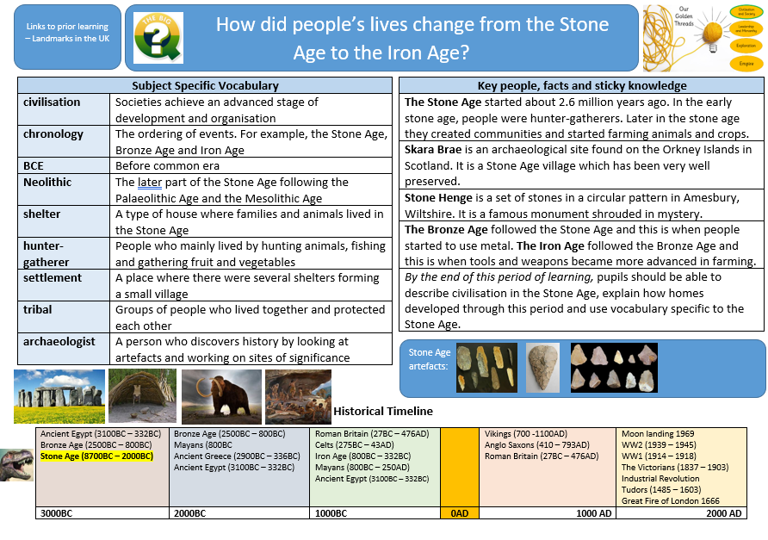
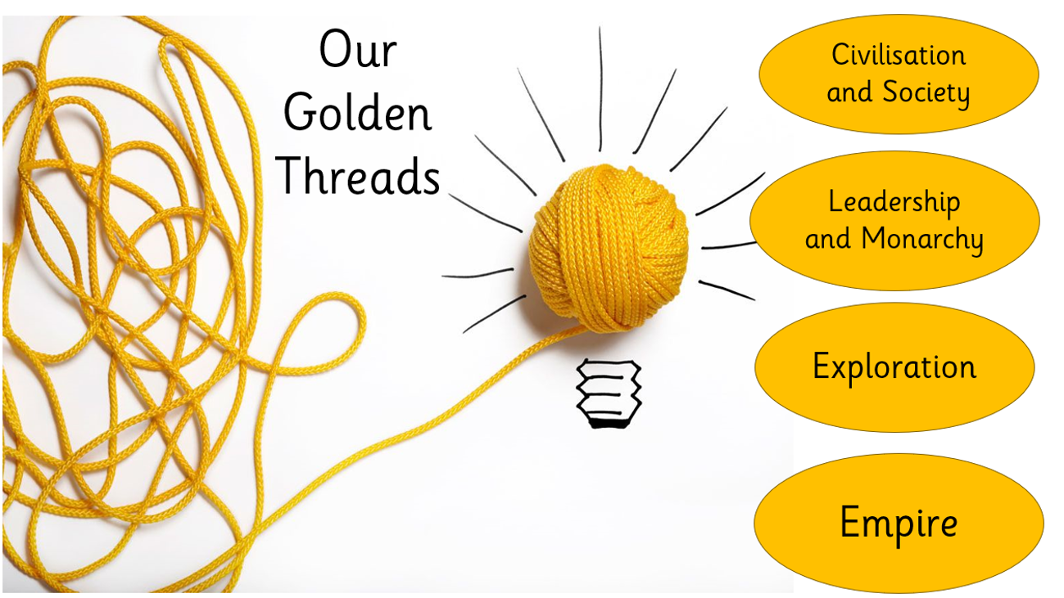
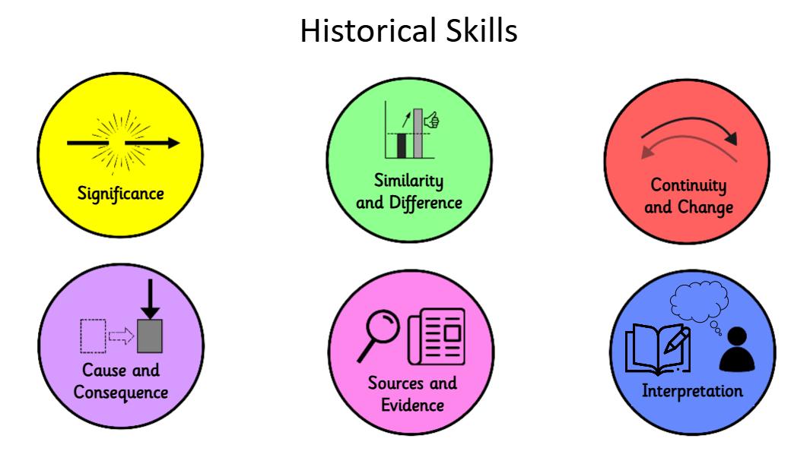
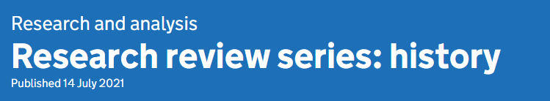
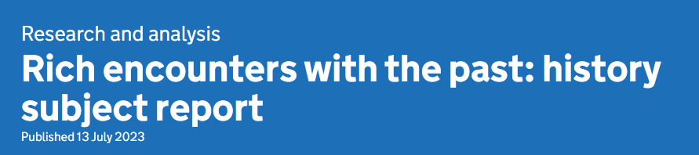
History
 | Autumn 1 | Autumn 2  Latchmere History Curriculum Map 2026-2027 | Spring 1 | Spring 2 | Summer 1 | Summer 2
Throughout the Early Years, children begin to develop an understanding of the past and present through the use of storytelling, songs, poems, puppets and role play. Fictional and non-fictional characters from a range of cultures and times are explored in storytelling.
Nursery | Marvellous Me/Let’s Celebrate!  - To show interest in the lives of people who are familiar to them.  - To remember and talk about significant events in their own experience.  - To enjoy joining in with family customs and routines.  - Begin to make sense of their own life story.  Adults model talk about leisure and family events outside nursery and encourage children to share their own family experiences.  Celebrate birthdays with cake and candles and model ‘I was 3. Now I’m 4.’ Children share how they celebrate their birthdays.  Celebrate Harvest, Divali, Bonfire Night, Christmas and emphasis similarities and differences.  Talk about how we are the same and different through our portraits. |  | Where do I live?/Animals  - To recognise and describe special times or events for family or friends.  - To know some of the things that make them unique and can talk about some of the similarities and differences in relation to friends or family.  - Begin to make sense of their own life story.  Encourage talk between children about recent past family celebrations such as weddings, the birth of babies and shared events with family and friends, such as holidays, playdates, visits to grandparents.  During ‘home’ role-play with babies, adults model baby related routines and talk with children about what they have been told about when they were babies. Share baby photos.  Match adult and baby animals. Observe the life-cycle of a duck and a frog.  Talk to Farmer Tom about baby and adult farm animals during farm visit. |  | What’s in the Garden? Let’s have an adventure!  - To look at changes over time.  - Begin to make sense of their own life story.  - To find out about their parents or grandparents adventures in childhood.  - To celebrate the King’s birthday – who was on the throne before him?  Observe the life-cycle of the butterfly and describe it.  Describe what they can do now that they could not do when they started nursery – write their name, skip, do their zip up.  Celebrate the King’s birthday. Know who King Charles is and the immediate royal family, through photos and video clips.
Vocabulary | Passing of time: today, yesterday,  Other: now, next, same/not the same, who? What? birthday, Christmas |  | Passing of time: days of the week, today, yesterday (Makaton), now, using the past tense – ‘I went to…’. Calendar. Starting to count down – ‘How many sleeps until the weekend?’ ‘Long ago’ in songs (There was a princess….) Remember.  Other: pancake day, Holi, The Lunar New Year, Easter |  | Passing of time: before, after, next, then, using the past tense – ‘I saw, went…’, older –‘I was 3. Now I’m 4’.
Addressing misconceptions | Children might not understand that yesterday is one day before today – duration of time. (Use Makaton and simple calendar to support understanding, reflect on what we did yesterday through photos) |  | Children might think that their friends have the same likes/dislikes, family routines as themselves. (Share favourite rooms, breakfasts, stories, characters etc) |  | Children might think that their parents and grandparents have always been grown- ups. (Encourage adult family members to share photos or memories of themselves as a child.)
Assessment | By the end of this period of learning, children should be able to name the people in their family and notice and begin to talk about some of the similarities and differences between themselves and someone else. For most children, they should be able to talk about a simple past event. |  | By the end of this period of learning, children should have an understanding of the passing of time and be beginning to use the past tense to talk about an event that has happened. |  | By the end of this period of learning, children should be able to explain the change of something over time (e.g caterpillar/butterfly, plant, duck). They will know that they were 3 years old and that now they are 4 years old. They will know that they have grown and changed from a baby into a child.
Key concepts | Similarities and difference, chronology (Moving photo from 3 to 4 years on their birthday. Weather – Today is sunny; yesterday was rainy.’)  Use of daily visual timetable) |  | Similarities and difference, chronology (daily calendar, weather chart, birthday display) |  | Similarities and difference, Monarchy, chronology (daily calendar, weather chart, birthday display)  A photograph from each week to reflect on.
Reception | All about me/Celebrations  - To find out about ourselves, our families and how we have changed.  - Comment on images of familiar situations in the past.  - Compare and contrast characters from stories, including figures from the past. |  | People who help us/Traditional tales/Farm/Easter  - To talk about past and present events in their own lives and in the lives of family members.  - To know about similarities and differences between themselves and others, and among families, communities and traditions.  - To show interest in different occupations or ways of life. |  | Lifecycles/Growing/Change/Adventures/Summer  - To find out about past and present events in our own lives and begin to think about the future.  - To look at our development over time.  - Develop understanding of growth, decay and changes over time  - Question why things happen and give explanations
Vocabulary | Passing of time: every year, afterwards, every day, weekly, daily  Other: Birthday, Harvest, Bonfire Night, Diwali, Remembrance Day, Hanukkah, Christmas, Thanksgiving, decorations, family, nativity |  | Passing of time: before, after, next, then, using the past tense, until, last week, last year, in the past, a long time ago |  | Passing of time: yesterday, tomorrow, before, after, next, then, using the past tense – ‘I saw, went…’
Addressing misconceptions | Passing of time – not understanding yesterday, tomorrow, last year (link to birthdays)  Parents were not babies/children – they have always been their parents  Jesus was born a short time ago |  | Children might think that stories from the past are set today – focus on the environment, objects from the past, artefacts to show the similarities and differences. |  | Either pirates don’t exist today or they exist how they did in the past.  The time it takes for things to change e.g. caterpillars, plants, travelling to the moon
Assessment | By the end of this period of learning, children will enjoy joining in with family customs and routines. Children will know about similarities and differences between themselves and others. They will use new vocabulary when talking and role play alongside others, using language to imagine and recreate roles. They will be able to create simple representations of events and people. |  | By the end of this period of learning, children will enjoy joining in with family customs and routines. Children will know about similarities and differences between themselves and others. They will use new vocabulary when talking and role play alongside others, using language to imagine and recreate roles. They will be able to create simple representations of events and people. |  | By the end of this period of learning, children will be able to observe how they have grown and changed from a baby, toddler to child and how family members are teenagers, adults or elderly. They will also have practised using vocabulary associated with the passing of time in reference to the life cycles of butterflies, plants and chicks.
Key concepts | Similarities and difference, chronology |  | Similarities and difference, chronology |  | Similarities and difference, chronology, Monarchy.
Year 1 | Geography focus this half term | Toys  - To develop an awareness of the past and use common words and phrases relating to the passing of time (past, present-day, future)  - Sort and describe toys and games from different eras within living memory (changes within living memory)  - Use a wide vocabulary of everyday historical terms: artefact, damaged, materials, hand-made)  - Find out about the past from a range of sources (videos, first-hand accounts from family members, books, artefacts) | Queens  - To study the lives of significant individuals in the past who have contributed to national and international achievements (Elizabeth I, Queen Victoria, Elizabeth II).  - To compare aspects of life (schooling, housing, employment, amenities, way of life) in different periods (Elizabethan, Victorian and present day)  - To know where the queens fit within a chronological framework and identify similarities and differences between ways of life in different periods. | Geography focus this half term | Geography focus this half term | Seaside Holidays Now and Then  - To know how holidays and leisure time have changed and why.  - Changes within living memory of seaside holidays.  - To find out about the past from a range of sources  - To ask and answer questions about the past
Big Question |  | How are toys we play with different to those played with 100 years ago? | What was life like during the reign of 3 powerful queens? |  |  | How have seaside holidays changed from in the past?
Historical Skills |  | To ask and answer questions about the past; make connections; Continuity and change; Similarity and difference | Similarity and difference |  |  | similarity and difference; cause and consequence (steam train)
Vocabulary |  | artefact, Victorian, old-fashioned, modern, material, handmade, factory built | monarch, monarchy, reign, empire |  |  | artefact, Victorian, seaside, holiday, coastline, promenade
Addressing misconceptions |  | Confusion with ‘old’ toys that are still made – are they old or new? | To confuse the Elizabethan times and the Victorian times – concept of time still developing |  |  | Children might think that the past was in black and white.  Children might think that people always had holidays and not understand that travel and time off was once a luxury for the rich.  Children might think that people always used cars and planes to get to the seaside.  Confusing UK and abroad beach holidays. Some children have never been to the UK beaches.
Assessment |  | By the end of this period of learning, pupils should be able to describe toys from the past and toys from modern times, identifying their similarities and differences. They should be able to identify the material the toy is made from and whether it is handmade or made in a factory. | By the end of this period of learning, the children should know the terms monarch, monarchy and reign. They should be able to compare the reign of each monarch. |  |  | By the end of this period of learning, pupils should be able to describe seaside holidays from the past and from modern times, identifying their similarities and differences.
Golden threads |  | Civilisation & Society | Leadership & Monarchy  Civilisation & Society |  |  | Civilisation & Society
Year 2 | Geography focus this half term | Geography focus this half term | The Great Fire of London  - Place events and objects in chronological order  - Recognise why people did things, why events happened and what happened as a result  - Identify differences between ways of life at different times.  - Identify and describe reasons for, and results of events and changes.  - To learn how the Great Fire of London started and spread.  - Describe and make links between events, and changes across periods  - To learn of the significant people during The Great Fire of London.  - Recognise the past is represented and interpreted in different ways, and give reasons for this  - Use a variety of sources to find out about events, people and changes | The Great Fire of London Continued (long unit)  Significant People:  Florence Nightingale  Learn about the lives of significant individuals in the past who have contributed to national and international achievements. | Trailblazers: Significant People  Nurses: Florence Nightingale, Mary Seacole, Edith Cavell  Explorers: Christopher Columbus and Neil Armstrong,  - Place events and objects in chronological order  - Learn about the lives of significant individuals in the past who have contributed to international achievements.  - Develop an awareness of the past, using common words and phrases relating to the passing of time.  - Learn where the people and events they study fit within a chronological framework and identify similarities and differences between ways of life in different periods.  - Compare.  - Find out some of the ways in which we find out about the past. | Local history people, places and events  Local history walk with guest speaker covering:  The coronation Stone – used to coronate seven Anglo Saxon kings  Three fishes – ancient coat of arms of Kingston recorded in 1572 and 1623 the fish represent the three fisheries as mentioned in the Doomsday book  Clattern Bridge - The bridge here, crossing Hogsmill River, is one of the oldest in Surrey. The oldest reference is from 1203 where it’s Medieval mouthful of a name is given as ‘Clateryngbrugge’, thought to be onomatopoeic of the horses clattering across the cobbled bridge.  Find out some of the ways in which we find out about the past: The Domesday Book.  Geography focus this half term
BIG Question |  |  | Why did the Great Fire of London happen and how did it change London? |  | How did trailblazers from the past change the world? | What do clues around us tell us about the history of Kingston?
Historical Skills |  |  | similarity and difference; significance (how the fire changed London and the invention of the fire service); cause and consequence | significance; similarity and difference | significance; historical perspective (how significant an event was this?) make connections; similarity and difference (the attributes of explorers);  Frame historically valid questions; similarities and differences, make connections | To ask and answer questions about the past, Use historical evidence, Significance.
Vocabulary |  |  | civilization, River Thames, rats, bakery, diary, Pudding Lane, drought |  | civilization, expedition, native, obstacle, navigator, solo, discovery, frostbite | monarchy, coronation, coat of arms, Anglo Saxon,
Addressing misconceptions |  |  | Children might think that the entire city was destroyed by the fire.  Children may think that everyone in London experienced the fire in the same way.  Children might believe that the fire eradicated the plague.  Children might believe that no-one died in the fire. |  | Children might think that Florence Nightingale Was the First Nurse and that nurses didn’t do much before her changes. They might think that she worked alone.  Some children may think that Christopher Columbus was the first person to ‘discover’ America. They may think he proved the earth was flat.  Some children may think Neil Armstrong was the first person to travel to space or that he was the only one to walk on the moon. | Some children may think that Henry VIII was crowned at the Coronation Stone confusing historical periods.  Some children may struggle to understand how far back in time the Anglo Saxon period was as they have not studied a period as far back as this before.
Assessment |  |  | By the end of this period of learning, pupils should be able to describe what started the fire, how it spread, why it spread, how it was stopped and how London was rebuilt. They should ask the question, ‘How did this change civilisation in London?’ |  | By the end of this period of learning, pupils should be able to name famous explorers and describe their achievements. | By the end of this period of learning, pupils should be able to identify different elements of local history. (Coronation Stone, Clattern Bridge and the three fisheries)
Golden Threads |  |  | Leadership & Monarchy, civilisation & society |  | Exploration | Leadership & Monarchy
Prior knowledge assemblies |  | Long and short timescales in history |  | The achievements and follies of mankind |  | Local, regional, national and international history
Year 3 | Stone Age to Iron Age  -To understand the term prehistory  -To know the three phases of the stone age  -To explain the progression of human development over time in terms of homes  -To learn about the late Neolithic hunter-gatherers and early farmers  -To understand the role of an archaeologist and what evidence they use from prehistory  -To understand what human developments defined the Bronze and Iron Age and how this advanced human existence. | Geography focus for this half term | Ancient Egypt Depth Study  - To know where Egypt is in relation to other countries.  -To place Ancient Egypt in a chronological frame.  - To know how the environment influences where people live. To understand how the Ancient Egyptians used the Nile in terms of trade and travel (the achievements of the earliest civilisations)  -To know about daily life in Ancient Egypt and use this knowledge to compare to the Stone/Bronze/Iron Age.  - To understand how our knowledge of the past is constructed from sources | Ancient Egypt Depth Study  - To use secondary sources to research important historical events (Newspaper reports/sources) – Howard Carter’s discovery of Tutankhamun  - To represent historical information-mummification-mummify a tomato. - -to use sources to ask questions about the past.  -To learn about religious beliefs in Ancient Egypt and how this contributed to achievements/civilisation. (Egyptian Gods/Goddesses)  Egyptian day- drama workshop  Visit to the British Museum  Overview of ancient civilisations  When and where the earliest civilisations existed; their achievements (Indus, Sumer, Chang, Egypt)  Comparison of achievements with Egypt | Romans  - To place the Roman Empire in a chronological frame.  -To understand the reasons for the Roman invasion of Britain. (linking to the end of the Iron Age)  - To understand the features of the Roman army.  - To know the reasons for the revolt of Boudicca and understand why she is an important figure of the time.  -To describe daily life for the Romans and identify some of their inventions | Geography focus for this half term
BIG question | How did people’s lives change from the Stone Age to the Iron Age? |  |  | What were the Ancient Egyptians most significant achievements? | What was the impact of the Romans on Great Britain?
Historical Skills | Similarities and differences (progression of homes); historical enquiry/interpretation (the artefacts at Skara Brae) |  | Cause and consequence (why the Egyptians settled by the Nile); similarities and difference (between the early civilisations) |  | Interpretation (Boudicca’s revolt); making connections (the legacy of the Romans on life today)
Vocabulary | civilisation, chronology, BCE, Neolithic, shelter, hunter-gatherer, settlement, tribal, archaeologist |  | civilisation, pyramid, hieroglyph, sarcophagus, mummification, papyrus, scarab beetle, Pharaoh, sphinx, cartouche |  | civilisation, empire, invasion, Emperor  Legion, mosaic, amphitheatre
Addressing misconceptions | Some children might associate the Stone Age with dinosaurs due to a misunderstanding of historical timelines. Children might think that everyone during the Stone Age lived in caves. |  | Children might think that every ancient Egyptian was mummified and that pyramids were the only type of buildings. They think that hieroglyphs are simple drawings or pictures, without understanding that they represent a complex writing system. They sometimes envision that everyone in Ancient Egypt lived in pyramids. |  | Children might think that all Romans were gladiators or warriors who fought in the Colosseum. Romans all wore togas.
Assessment | By the end of this period of learning, pupils should be able to describe civilisation in the Stone Age, explain how homes developed through this period and use vocabulary specific to the Stone Age. |  | By the end of this period of learning, pupils should be able to describe civilisation in Ancient Egypt, explain the historical significance of Howard Carter’s discoveries, describe how the Nile was used and use vocabulary specific to the Ancient Eqyptians. |  | By the end of this period of learning, pupils should be able to describe how the Romans influenced British civilisation and the legacy left behind by referring to: place names, roads, bridges, viaducts, aqueducts, underground drainage, Christianity, language and new produce (fruit and vegetables). They should also describe Boudicca’s revolt.
Golden Threads | Civilisation & Society |  | Civilisation & Society |  | Civilisation & Society, Empire
Year 4 | Geography focus this half term | Anglo Saxon England  - To recognise how the fall of the Roman Empire led to the coming of the Anglo Saxons.  -To find out who the Anglo-Saxons were and where they came from.  -To find out who the Picts and Scots were and where they lived.  -To be able to use various historical sources to find out about Anglo-Saxon life.  -To study the archaeological evidence at Sutton Hoo to ask and answer questions.  -To use what has been discovered at Sutton Hoo to draw conclusions about who was buried there.  -To explore Anglo-Saxon culture including art, music, legends and poetry.  - To explore the spread of Christianity in Britain. | The invasion of the Vikings  Who were the Vikings and where did they come from?  Why did the Vikings raid and settle in Britain?  What was life like for a Viking in Britain?  How did the Anglo-Saxons respond to the Viking threat?  What was the impact of the Viking invasion on Britain?  What is the legacy of the Vikings in Britain today? | Geography focus this half term | The Tudors – local history study  Henry VIII and Hampton Court  -To discover the history of the Tudors and their beginnings.  -To understand the impact of Henry VIII on Britain.  -To identify and describe reasons for, and results of events and changes.  -To ask and answer questions. Select and record relevant information. To use dates and historical vocabulary to describe the period.  - Tudor England – Hampton Court daily life of the rich and poor, including housing, clothing, food, education, and entertainment.  -To look at the local site and to evaluate how the Tudors have had an impact. | Geography focus this half term
BIG question |  | What impact did the Anglo-Saxons have on Britian and how do we know? | Raiders, Traders or Settlers? Why did the Vikings come to Britain and what was their impact? |  | How did Tudor monarchs shape England and how did England?
Historical Skills |  | Continuity and change (what stayed the same in terms of housing following on from the Iron Age?) | Cause and consequence of invasion |  | Frame historically valid questions; interpretation (of paintings); cause and consequence (the break with Rome)
Vocabulary |  | civilisation, Aesir, | Jorvik, invade, longhouse, longship, raid, rune, Scandinavia, Viking |  | civilisation, empire, peasantry, parliament, banquet, jousting, wattle and daub, jetty, Battle of Bosworth
Addressing misconceptions |  | The Anglo-Saxons were from Britain. That they were a singular unified group; in fact they were a collection of various Germanic tribes. Also, they were not simple and tribal, they had well-developed social structures. | Some children might think the Vikings wore horned helmets.  They might think that Britain was always a Christian country.  Children might think Vikings only came to England to fight and pillage. |  | Children may think that Great Britain was always a Church of England country.  Henry VIII was the only Tudor monarch.  Some children may think that all of Hampton Court was built for Henry VIII and that it was all built at the same time.
Assessment |  | By the end of this period of learning, pupils should be able to describe who the Anglo Saxons were and what impact they had on civilisation in Britain. | By the end of this period of learning, pupils should be able to describe who the Vikings were and what impact they had on civilisation in Britain. |  | By the end of this period of learning, pupils should be able to describe life in the Tudor times, explain what happened to each of Henry VIII’s wives and describe the monarchy at the time.
Golden Threads |  | Exploration, Civilisation & Society | Civilisation & Society |  | Leadership & Monarchy
Year 5 | Geography this half term | Victorians 1  To identify when the Victorian era began, who ruled Britain at the time, and what early events marked the beginning of the period.  To understand how industrialisation changed where and how people lived.  To investigate working conditions for children and adults in Victorian Britain.  To identify key Victorian inventions and explain their impact.  To understand how Victorian medicine and public health changed. | Victorians 2  To explore what Victorian school life was like and who could attend.  To understand what the British Empire was and how it affected Britain and its colonies.  To identify lasting impacts of the Victorian era on modern Britain.  To use evidence to answer the big question. | Ancient Greece 1  Pupils will study Greek life and achievements and their influence on the western world.  -To place the Ancient Greek civilisation on a timeline  -Learn that ancient Greeks had their own school system and alphabet, to recognise similarities and differences between this and our own era.  -To understand how Greek pottery was used as a tool to commemorate  significant events  -To learn about ancient Greek gods and goddesses and their religious beliefs and compare this to other eras. | Ancient Greece 2  - Learn about the contribution made by Greek scholars and their influence on the Western World  - To know what is meant by democracy  - To learn about how the Olympic Games have changed over time and how they have stayed the same  - To use a variety of artefacts and sources to learn about the past – Homer’s Odyssey | Geography this half term
BIG question |  | What was life like for different people during the Victorian era, and how did the Victorian era change Britain? |  | How did the Ancient Greeks influence the world we live in today?
Historical Skills |  | Make connections (inventions); similarities and differences (education); historical perspective (trade, laws, acts); frame historically valid questions (What has been the effect of the industrial revolution on today’s society?): Cause and consequence (industrial revolution) |  | Make connections (education, democracy); similarities and differences (education); follies of mankind
Vocabulary |  | civilisation, empire, industrialisation, revolution, poverty, invention, manufacture  reform, suffrage |  | civilisation, empire, Athens, Sparta, philosophy, democracy, Olympics, Zeus
Addressing misconceptions |  | The empire – indigenous people were typically treated unfairly by the invading British. Some might believe that they were treated well.  There also might be a misconception that the divide between rich and poor only appeared in the Victorian times but this was represented through peasantry in the Tudor times.  Healthcare did exist before the Victorians – but in a more basic way. |  | The ancient Greek period is 800 BCE to 300 BCE roughly (but some sources say 1300 BCE) and BCE years decrease in number as time goes by (this still confuses children).  The Ancient Greeks are often credited with the birth of democracy, but citizenship was not given to slaves and women.  Olympic torch lighting wasn’t a Greek idea.  Technological achievements of ancient Greece are underrepresented.
Assessment |  | By the end of this period of learning, pupils should be able to describe the impact of the Industrial Revolution on the Victorian era and beyond, describe life in the mines and factories for children, describe various reform acts which came into place and reflect on the impact the Victorian era had on civilisation thereafter. |  | By the end of this period of learning, pupils should be able to describe civilisation in Ancient Greece and explain how the Ancient Greeks influenced the world through sport, architecture, warfare, democracy, religion and literature.
Golden Threads |  | Empire, Civilisation & Society, Monarchy, |  | Civilisation & Society
Year 6 |  | The Maya  - To place the Maya civilisation in time and place, and compare it to other periods studied.  - To describe what life was like in a Maya city and understand the different roles people played.  - To understand the role of the Maya king and how power and leadership were viewed.  - To explain Maya religious beliefs and the role of priests in society.  - To compare the daily lives of different people in Maya society and consider how class affected experience.  - To present informed ideas about Maya society and formulate meaningful questions for a king, priest, and farmer. | The British Empire  - To understand the definition of an empire and the key characteristics of the British Empire.  - To identify objects which contributed to the wealth of the British Empire.  - To learn about a significant figure during the British Empire: Gandhi  - To understand the factors which led to the end of the British Empire. |  | World War II  -To identify connections between British, local and world history  -To identify and describe reasons for historical events. What was the Second World War? When and where did it take place?  -To select and combine information from different sources. Why were children evacuated? What was it like to be an evacuee?  -To evaluate sources of information. What precautions were taken against attack?  -To identify and describe reasons for historical events. What was the Blitz? Which areas were particularly affected?  -To recognise that the past may be interpreted in different ways. What is ‘propaganda’?  -To recognise the characteristic features of a historical period. How did the role of women change during the war?  -To make links between the main events and situations within a historical period. Why was rationing introduced? What was rationing?  -To evaluate first-hand evidence of an historical period. What was it like to be a child living in World War Two?  -To select and record information relevant to the focus of an historical enquiry. How did the war end? How was VE Day celebrated?  -To make links between pivotal events that led to a significant change in the time period.  -To make links between events from the past and in the present. What conflicts are happening in the world today? Is the world better today since the end of World War Two?
BIG question |  | If you could travel back in time to an ancient Maya city at its peak, what would you see and what questions would you ask a king, a priest, and a farmer? | What events led to the rise and fall of the British Empire? |  | Why was the Battle of Britain considered a turning point in WW2?
Historical Skills |  | Make connections ; compare and contrast – different people’s experience depending on their role in society, similarities and difference (societal roles compared to Saxon, Tudor, Victorian); cause and consequence - Maya kings and how leadership and power were viewed; frame historically valid questions, | Cause and consequence, similarities and differences (how Gandhi dressed); significance |  | Cause and consequence (role of women due to men leaving for war; evacuation); historical interpretation (bias from newspapers); frame historically valid questions; historical enquiry
Vocabulary |  | civilisation, empire, legacy, Chichen Itza, city state, hieroglyphs, codex/codices, cacao, sacrifice | colony, empire, prejudice, liberation, oppression, independence, fasting |  | civilisation, empire, blitz, air raid, Luftwaffe, Spitfire, Lancaster Bomber, allies, evacuation, Nazi
Addressing misconceptions |  | The Mayans, Aztecs and Incas were all the same group of people.  The Mayans and the rest of the world had knowledge of each other.  Christopher Columbus discovered was Spanish and discovered America. | Thinking USA is part of the British Empire.
Assessment |  | By the end of this period of learning, pupils should be able to describe aspects of the Mayan era drawing on their knowledge of civilisation and their way of life. | By the end of this period of learning, pupils should be able to:  -recognise that Britain’s past history, particularly the Victorian era, may be interpreted in different ways.  -identify key moments in Gandhi’s life, giving reasons for their significance.  -understand the power of peaceful protest in bringing about fundamental political and social changes.  - describe the key characteristics of the British Empire.  - explain the factors which led to the end of the British Empire. |  | By the end of this period of learning, pupils should be able to describe the role of the empire in WW2, how WW2 affected civilisation in Britain and beyond, the consequences of evacuation and how the war ended.
Golden Threads |  | Exploration, Civilisation & Society | Empire |  | Empire, civilisation and society

