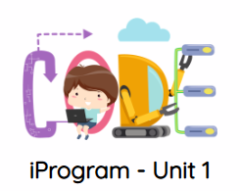

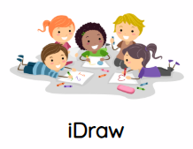
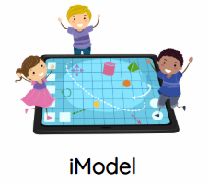
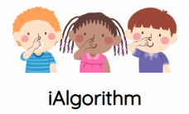
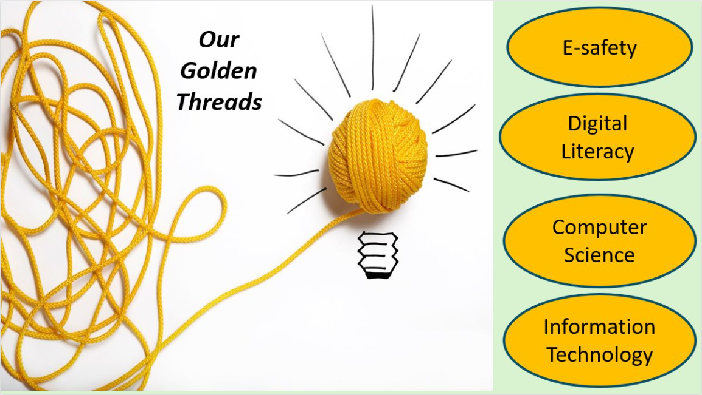
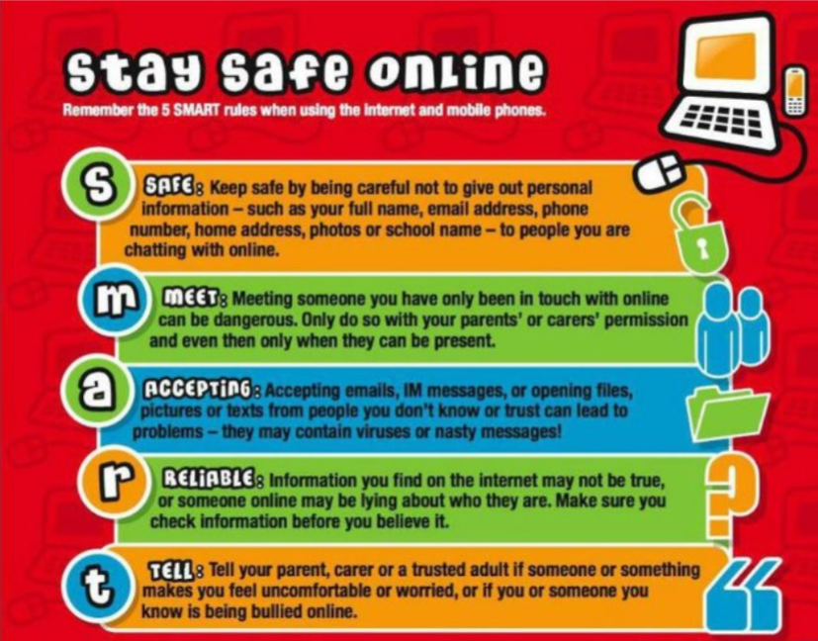

Computing
 | Autumn 1 | Autumn 2 | Spring 1  Computing Curriculum Map 2026 - 27 | Spring 2 | Summer 1 | Summer 2
The Early Years Foundation Stage | The EYFS framework is structured differently from the National Curriculum as it is organised across seven areas of learning rather than into subject areas. Skills taught across the EYFS feed into the National Curriculum subjects. The prerequisite skills for Computing within the national curriculum are detailed in Development Matters 2021, particularly in the following areas of learning: Personal, Social and Emotional Development, Physical Development, Understanding the World and Expressive Art and Design. Computer hardware and software may be used across the EYFS curriculum at different times during the year to support their learning across the seven areas.  Technology in the classroom -Calculator, whiteboard, iPad, Beebot, CD player, tills, keyboards. Technology at home/out and about – Phone, television, hoover, toys, music players, DVD players, Gaming Devices, pedestrian crossings, drinks machines, scanners.  What does this do? How does this work? What happens when I press this? What can I use this for?
Nursery | iStay Safe  To understand that the internet can be used to go places and to learn from.  To compare staying safe online to staying safe in the real world. | iCan Sequence  To understand that there are steps in a sequence to completing a task.  They follow the ‘sandwich’ algorithm to make a sandwich with adults giving instructions. | iMake Algorithms  Sequencing nursery rhymes  To understand that nursery rhymes involve sequences.  To create a flow chart of the sequence together. | iCan Turn  To program a toy to move and make turns. | iOrganise Data  To understand that objects can be used to represent data. | iCan Model  To compare real life and virtual situations.  Begin to understand that computers can represent real life situations.  Dress Teddy
Vocabulary | internet, online, website, safe | order, steps, instructions, algorithm | sequence, steps, order, pattern, repeat | program, instruction, forwards, backwards, distance, measure (by counting steps) | data, information, graphs, represent | real, pretend, imaginary, model
Addressing misconceptions | Children may think that it is safe to go anywhere or to talk to anyone on the internet. | Children may not understand that order makes a difference to the outcome. Stress this during all activities that require sequence. | Children may not understand the language or concept of sequence. Use Makaton and widget nursery rhyme sequence cards to support. | Children may not understand that separate, accurate commands need to be given to achieve the outcome they expect. They may think they can press buttons randomly. | Children may not understand the concept of representation.  Children may not understand that data is information, particularly that it is disorganised or ‘unfinished’. | Children might confuse dressing in real life with virtual dressing. They might think they have additional choices, whereas there are set or limited choices in computer representations. Order of dressing may also be misunderstood. Dress a real teddy with different choices.
Assessment | Understand they should ask an adult’s permission before they go online.  Understand they should not talk to anyone they do not know on line. | Follow simple instructions in order with help. Identify steps of a known task. Know that changing steps changes outcomes. | Identify key events in a nursery rhyme with support. Organise events in order, not always accurately. Understand that some everyday activities involve steps. | Give simple commands to a programmable toy to travel in a straight line, then turn. Understand that changing commands changes outcomes | Demonstrate understanding of pictures representing data via a pictogram | Relate some computer models to real life.  Explore simple computer models.  Begin to understand that computers can be used to represent some real life and imaginary situations.
Key concepts  (Golden Threads) | Digital Literacy | Digital Literacy | Computer science | Computer science | Computer science | Information Technology
Topic | E-Safety | How to / how it works | Algorithms | Programming | Data | Art, Design and Media
E-Safety across the curriculum | E-Safety | E-Safety | E-Safety | E-Safety | E-Safety | E-Safety
Reception | iStay Safe  Children talk about similarities between staying safe online and in the real world.  Children can explain rules for staying safe online. | iCan Sequence  To understand that there are steps in a sequence to completing a task.  They follow the ‘sandwich’ algorithm to make a sandwich. | iMake Algorithms  To understand that nursery rhymes involve sequences.  To create a flow chart of the sequence together. | iCan Turn  To program a toy to move and make turns.  Design a simple trail involving turns and give the toy the commands to follow the route. | iOrganiseData  To understand that objects can be used to represent data. | iCan Model  To compare real life and virtual situations.  Begin to understand that computers can represent real life situations.  Simple City
Vocabulary | Internet, online, website, safe | Order, steps, instructions, algorithm, sequence, first, second, next, then | Sequence, steps, order, pattern, repeat, flowchart, before, after, next, last | Program, command, instruction, forwards, backwards, distance, measure (by counting steps), exactly, turn | data, information, graphs, represent | Real, pretend, imaginary, model
Addressing misconceptions | Children may think that it is safe to go anywhere or to talk to anyone on the internet. | Children may not understand that order makes a difference to the outcome. Stress this during all activities that require sequence. | Children may not understand the language or concept of sequence. Use Makaton and widget nursery rhyme sequence cards to support. | Children may not understand that separate, accurate commands need to be given to achieve the outcome they expect. They may think they can press buttons randomly. | Children may not understand the concept of representation. Children may not understand that data is information, particularly that it is disorganised or ‘unfinished’. | Children might confuse dressing in real life with virtual dressing. They might think they have additional choices, whereas there are set or limited choices in computer representations. Order of dressing may also be misunderstood. Dress a real teddy with different choices.
Assessment | Understand they should ask an adult’s permission before they go online. Understand they should not talk to anyone they do not know on line. | Follow simple instructions in order with help. Identify steps of a known task. Know that changing steps changes outcomes. | Identify key events in a nursery rhyme with support. Organise events in order, not always accurately. Understand that some everyday activities involve steps. | Give simple commands to a programmable toy to travel in a straight line, then turn. Understand that changing commands changes outcomes | To demonstrate an understanding of representation via a pictogram | Relate some computer models to real life.  Explore simple computer models. Begin to understand that computers can be used to represent some real life and imaginary situations.
Key Concepts  (Golden Threads) | Digital Literacy | Digital Literacy | Computer science | Computer science | Computer science | Information Technology
Topic | E-Safety | How to / how it works | Algorithms | Programming | Data | Art, Design and Media
E-Safety across the curriculum

Year 1 | iSafe  To understand what being online may look like, and the different feelings we can experience online.  To understand how photos are shared  To understand the importance of seeking permission to post photos  To understand how to approach adults to help with online activities  To understand that people online may try and manipulate others, how this can make someone feel and how to identify approach adults who can help. | iLearnAI  To understand that intelligence can be simulated by machines  To learn about everyday AI applications  To understand that computers learn using information given to them by people  To understand that artificial intelligence (AI) may not always be accurate or reliable. | iAlgorithmn  To understand that algorithms are precise instructions that can be followed.  To follow a simple algorithm.  To devise a simple algorithm.  To understand that programs execute by following precise and unambiguous instructions.  To test and debug a simple algorithm.  To predict the outcome of an algorithm.  To understand conditions and outcomes. | iProgram  To understand that algorithms are  implemented as programs on a range of digital devices.  To give instructions to a programmable toy.  To plan a simple algorithm to that  controls a toy.  To program a virtual object to move toon-screen objects.  To record a sequence of instructions in a common format. | iData  To conduct a survey and produce a pictogram.  To create a graph using digital tools.  To create a pictogram using collected data.  To sort information and present data using a graph.  To learn how real life and pretend environments can be created with computers  To investigate ‘mark making’ computer tools  To re-create art by a famous artist using a computer  To explore a range of drawing tools | iWrite  To produce text in different ways.  To use software to create and change text  To understand that a computer can be connected to a printer  To use word processing software to create text  To open and save a word processing document  To create a story using a word processor and word banks  To practice keyboard skills and type descriptions of themselves
Vocabulary | online activities, communication, safety, online safety, personal information | artificial intelligence (AI), program, command, simulate, example, categorise, predict, mistake, prompt | algorithm, instruction, sequence, program, debug, repeat, true, false | algorithm, instruction, sequence, program, debug, repeat, output | art, draw, line, fill, artist, real/pretend, pen, brush, erase, 2d (2 dimensional) | words, sentences, word processing, changing, creating, mistakes, correct
Addressing misconceptions | Children may not understand that permission is required to post certain images or information.  Children may not be aware that the internet is not always a safe place | Children may be unaware that machines and computers have to be ‘taught’ by humans. | Children may be unaware that ordering is key to algorithmic processes and that precision is needed to elicit desired results. | Children may be unaware that ordering is key to algorithmic processes and that precision is needed to elicit desired results. | Children may not be aware of the term data and that data itself is not always useful. Data needs to be processed to become useable. | Children may be unaware that word processing is driven by humas – it is not an automatic process.
Assessment | Understand that various information is personal (e.g. hobbies)  Can usually identify characteristics of trustworthy people  Know that personal information should only be given to trusted people  Can give examples of when it may and may not be appropriate to share  pictures  Knows that people can bully and be bullied online | Demonstrate an understanding that AI is generated by computers but that the information was originally created via human input. | Read a set of instructions and usually predict the correct outcome.  Give simple instructions to make things happen and understand that this is called an algorithm.  Make changes to instructions if they are wrong | Read a set of instructions and usually predict the correct outcome.  Produce a set of instructions which others can usually follow. | Collect data and construct simple graphs and charts.  Make observations about graphs.  Answer simple questions using graphs.  Make statements about the information simple graphs tell them.  Ask questions about graphs.  Enter information into a graphing tool. | collect data and construct simple charts and graphs  make observations about graphs  answer simple questions using graphs  make statements about the information simple graphs tell them  ask questions about graphs  enter information into a graphing tool
Key concepts  (Golden Threads) | Digital Literacy | Digital Literacy | Computer science | Computer science | Computer science | Information Technology
Topic | E-Safety | How to / how it works | Algorithms | Programming | Data | Art, Design and Media
E-Safety across the curriculum

Year 2 | iSafe  To understand what personal information is  To understand that personal information is specific to each person  To understand when it is safe to give out personal information  To understand how to identify people that are worthy of trust  To understand that emotions can be a tool to help judge situations  To understand that physical sensations can alert us to danger  To understand the importance of checking with an adult before participating in an online environment. | iDomail  To understand that messages can be sent electronically over distances.  To understand that sent messages can be replied to and that conversations can happen.  To understand that communication can take the form of messages, sound, text and/or video. | iProgram  To understand algorithms can describe everyday activities and can be followed by humans and computers.  To understand that algorithms are made up of steps, some of which can be repeated.  To understand that algorithms are made up of steps, some of which can be repeated.  To program a simple animation involving movement. | iProgram 2  To program an animation using motion blocks.  To use sequence, triggers, and movement in computer programs.  To use sequence, selection and repetition in computer programs.  To use events, triggers and sequences in programs.  To understand the importance of planning a computer program | iSearch  To understand that the world wide web contains large amounts of information.  To use links to navigate a website.  To know that the world wide web can be used to answer questions.  To find answers to questions by following hyperlinks.  To locate specific information using a website.  To collect information from several different websites. | iPub  To understand the world wide web and how it has developed throughout time.  To consider how technology changes with time.  To share knowledge through multi-media presentations.  To plan/produce a presentation of research findings.  To create an interactive eBook.
Vocabulary | Online activities, communication, safety, online safety, personal information | Email, send, receive, attachment, attach, address, log in, email account | algorithm, instruction, sequence, program, repeat, test, debug | algorithm, instruction, sequence, program, repeat, test, debug | World wide web, network, internet, hyperlink, search, URL | World wide web, network, internet, device, E-Book
Addressing misconceptions | Children may be unaware that posting pictures or information online can be dangerous and that the online world can create feelings in the same way that real life can. | Children may not understand the immediacy of email as compared to physical letters or that various media can be attached to messages | Children may be unaware of the importance of ordering or that a single error can result in the program not working. | Children may approach programming via a trial-and-error approach, rather than pre-planning and ordering steps. | Children may assume that the internet is ‘fixed’ rather than a constantly evolving resource. Children may be unaware that websites link to each other, allowing users to follow ‘trails’ of information. | Children may be unaware that video and audio can be included into multimedia presentations.
Assessment | Understand that various information is personal (e.g. hobbies)  Can usually identify characteristics of trustworthy people  Know that personal information should only be given to trusted people | Login to an email provider  Send an email  Reply to an email  Attach items to an email | Execute a short series of commands that results in an effect.  Move a sprite in one direction on screen using steps.  Program and test a simple program. | Execute a sequence of commands that results in effects.  Move a sprite in more than one direction on screen using motion blocks.  Use trigger blocks to make something happen.  Switch scenes in a simple program using page blocks.  Program and test a simple program. | Use a link to find a website.  Confidently navigate a website.  Select information in a website.  Find answers to questions using a website.  Discuss their findings. | Combine text, images and audio to provide information on a topic.  Edit to improve, including using text styling and adding appropriate images.  Publish eBooks.
Key concepts  (Golden Threads) | Digital Literacy | Digital Literacy | Computer science | Computer science | Computer science | Information Technology
Topic | E-Safety | How to / how it works | Algorithms | Programming | Data | Art, Design & Media
E-Safety cross curriculum |  |  | PSHE – Introduction to the internet  To understand what the internet is and how it can help us.  To understand how to stay safe when using the internet.
Year 3 | iSafe  To recognise when something encountered online does not feel right  To identify some of the risks of sharing publicly online  To understand some measures that can be taken to stay safe  To raise awareness about appropriate and inappropriate content for online sharing  To understand potential consequences of sharing without consent  To understand some of the ways we can protect ourselves online against manipulation  To understand the ways the internet can make young people feel about themselves  To understand the need for strong passwords  To identify several different forms advertising can take online | iNetwork  To understand what a network is.  To know key parts of a computer network.  To understand that the internet is the physical connections between computers and networks.  To understand that devices on networks have a unique address. | iProgram  To understand that a program is a sequence of statements written in a programming language (Scratch)  To program an animation that executes a sequence of statements.  To understand that programs with graphics use x/y coordinates.  To program a sequence of instructions that create visual effects.  To understand that algorithms and programs can involve repetition.  To use a repeat function to draw a 2D shape.  To combine images, sounds and movement to create a personal animation. | iProgram 2  To understand that physical devices can be  Programmed  To understand that computer programs  consist of a set of instructions that can be followed by a robot  To use sequence and repetition in programs  To understand that robots can respond to  surroundings using sensors  To understand that behaviour can be programmed to respond to data from sensors  To understand that objects in the real world  move using gears  To demonstrate their understanding and skills about robotics | iData  To understand how information in a database is organised.  To understand the advantages of a computer-based database over a paper one.  To find and enter information to create additional records in a database.  To demonstrate the knowledge skills and understanding they have learned during this unit. | iPodcast  To understand that technology can be used to control sound.  To understand that sound can be stored digitally  To understand what a podcast is.  To plan and record a podcast.  To use digital tools to edit a podcast.  To combine audio sound and effects.  To identify the good features of a podcast.  To recognise improvements that could be made to a podcast.
Vocabulary | like, dislike, post, public, private, comment, share, threat, manipulation, pressure, flatter, share | network, network switch, server, WAP, WIFI, router, internet, IP address, URL, DNS | programme, sequence, selection, repeat, coordinates, x-y axis, import, test, debug | program, code, instructions, repeat, motor, sensor, direction, data, design | field, record, database, data, search, sort | audio, sound, record, playback, microphone, speaker, headphones, input, output, data, crop, trim, edit, pause, play, repeat, delete, save, mix, audio, effects, evaluate, feedback, quality
Addressing misconceptions | Children may not understand that content posted online is ‘permanent’ and cannot be removed. A clear link between real life situations and feelings and online activity should be demonstrated – online situations result in the same emotions as real world. | Children may not understand that computers are linked and that devices do not exist ‘separately’ of each other. | Children may be unaware of the importance of ordering or that a single error can result in the program not working. Many children will be unaware of how co-ordinates work and how they can apply to on screen features. | Children may not understand that a robot or computers actions are rooted in actions taken by humans (programming). A robot cannot work without instructions being given to it – it is not autonomous. | Children may not understand that a database is a collection of adapted data. Raw data should be explained as being unorganised or unprepared for analysis. | Children will be unaware of the practicalities of recording (ensuring appropriate recording levels), ensuring that equipment is used effectively. Some children may be unaware that audio is often edited before being presented but that podcasts are generally ‘live’ without edits.
Assessment | To know some of the ways people can be influenced online  Understand that some online content may be advertising  identify some of the risks of communicating and collaborating online and act to minimise them  know ways technology can be used positively and what is appropriate to share online  demonstrate the use of basic safety measures when using technology and working online  Know the need to use secure passwords and to keep them private | Demonstrate that a network is two or more devices connected.  Can identify different devices within a network. | Execute a sequence of commands that results in a planned effect.  Move a sprite around the screen using turns and repetition.  Program and test a simple program. | Construct a model  Use sequence and selection in programs to make a model move  Detect and correct errors in programs  Evaluate own work and that of others to suggest improvements | Know that databases and graphs are sued for different purposes.  Collect data from the internet to enter into a database. | Demonstrate an understanding of how audio files are created (a digital recreation/ of analogue sound) and to show an ability to create, record and store audio files.
Key concepts  (Golden Threads) | Digital Literacy | Digital Literacy | Computer science | Computer science | Computer science | Information Technology
Topic | E-Safety | How to / how it works | Algorithms | Programming | Data | Art, Design & Media
E-Safety cross curriculum |  |  | PSHE - Understanding cyberbullying  To understand that cyberbullying involves being unkind online |  |  | E-Safety
Year 4 | iSafe  Distinguish between personal information, which is safe to share online, and private information, which is unsafe to share.  Generate solutions for dealing with cyberbullying.  Experiment with different keyword searches and compare their results.  Understand plagiarism and its consequences.  Identify the characteristics of strong passwords.  Explore strategies for safely managing unwanted messages  Analyse why private information should not be given to anyone online without the permission of a trusted adult. | iLearnAI  To understand the basic concepts of AI  Identify examples of AI in everyday life.  To understand that computers are taught to learn and that this process is called ‘machine learning’.  To understand that computers learn using information given to them by people.  To understand the importance of using high quality data to train and test a machine learning model | iProgram 2  To understand that a program is a sequence of statements written in a programming language (TurtleArt).  To program a turtle to execute a sequence of statements.  To understand that computer programs consist of statements that perform a specific task.  To amend an algorithm to change the size of a shape.  To design a program that makes choice.  To combine repetition and conditional statements into a program. | iProgram 3  To solve problems by  splitting them into smaller parts (decomposition)  To plan and develop  algorithms and programs  To use repetition in  programs | iData  To understand that computers represent data as numbers and count using switches of ‘on’ and ‘off’ (0 and 1).  To sort record cards using field names.  To understand that storing information in an organised way helps answer questions.  To search a database to answer questions.  To use the information in a database to create a simple chart. | iAnimate  To understand what an animation is.  To create a scene for an animation.  To understand that animations can be created using digital tools.  To create an animated scene.  To storyboard and create a short animation
Vocabulary | Privacy, privacy settings, keywords, copyright, strong password, spam, virus, cyberbullying | intelligence, artificial intelligence (AI), machine learning, data, training data, testing data, model, learning model, prediction, input, | Program, sequence, selection, condition, repeat, test, debug, code, instruction, command, variable, execute | Program, sequence, selection, condition, repeat, test, debug, code, instruction, command, variable, execute | Forward, left, right, sequence, command, jump, execute, procedure, abstraction, repeat, call, decomposition | Image, camera, animation, stop, motion, illusion, onion skin, animator, frame, dimension, effects, onion skinning, frame rate, FPS (frames per second), CGI, GIF *graphic interchange format), 3D, design, plan, animate, storyboard, test, debug, edit
Addressing misconceptions | Children may not fully understand the implications of certain, personal details being made public. Certain information that is confidential can be uncovered via names, addresses, club memberships etc. | Children should be aware that AI is not fully automated. Human input is needed to enable machine learning. The ‘quality’ of AI is dependent on the input into computers by humans. | Children may not understand that a robot or computers actions are rooted in actions taken by humans (programming). A robot cannot work without instructions being given to it – it is not autonomous. | Children may be unaware of the importance of ordering or that a single error can result in the program not working. Many children will be unaware of how co-ordinates work and how they can apply to on screen features. | Children may be aware that a database is distinct from data in that the information contained is organised and arranged to enable searching and reference. | Children should be aware that animation exists in various forms outside of computer-generated content and that animation has its basis in human art. Computer generated animation is driven by human creativity, not by the computers themselves (similar to AI).
Assessment | Use technology to communicate and collaborate, identify some of the risks and act to minimise them.  Use search criteria to find relevant information online.  Demonstrate the use of basic safety measures when using technology and working online.  Know the need to secure passwords and keep them private. | To demonstrate an understanding of AI being human driven (information on the internet being created by humans).  To understand that AI created content should be subject to scrutiny as it may contain bias (depending on the creator of the original information). | Instruct a turtle to make half and quarter turns.  Use repeat commands.  Change commands and parameters to resize or change a shape.  Predict the outcome of a given algorithm or program. | Instruct a turtle to make half and quarter turns.  Use repeat commands.  Change commands and parameters to resize or change a shape.  Predict the outcome of a given algorithm or program. | Write and amend computer programs  Recognise patterns of commands and program simple procedures  that are repeated  Predict the outcome of an algorithm or program  Test computer programs and correct any errors | To demonstrate an awareness of the various steps in creating a short animation.  To show an ability to critique and subsequently edit content to meet a requirement (aesthetic or practical)
Key concepts  (Golden Threads) | Digital Literacy | Digital Literacy | Computer science | Computer science | Computer science | Information Technology
Topic | E-Safety | How to / how it works | Algorithms | Programming | Data | Art, Design & Media
E-Safety cross curriculum |  |  | PSHE - Online Information  To understand age restrictions on the internet  To understand that not all information online is truthful or valuable  To understand the risks associated with the fast-paced spread of information online
Year 5 | iSafe  To explore and identify methods of communication.  To understand why people, communicate.  To understand the risks and benefits of various modes of communication.  To understand the concept of personal and private information.  To understand safety  Rules and responsible behaviour when  Using new technologies.  To explore how and why we share information, give information and receive information  To explore the validity of online content  To begin to make sensible and considered judgements about whether to trust online content and people when online  To understand how to chat safely and sensibly  To explore the differences between online bullying and more traditional forms of bullying | iWeb  To understand that the worldwide web is one of the services offered by the internet  To know that the world wide web consists of many websites and web pages via the internet  To understand that many people remix content to work on the worldwide web  To know that HTML gives a website structure  To change a picture on a website  To read basic HTML code  To understand HTML provides structure for web content  To use research for the creation of a website  To upload an image for insertion into a website | iCrypto  To understand that messages can be sent and received secretly.  To learn encrypt/decrypt simple messages.  To understand signalling is a form of communication.  To understand that data can be transmitted as binary (on or off).  To encode/decode messages using a simple shift cipher.  Understand the algorithm of a simple shift cipher.  To understand the importance of cryptography historically and today. | iProgram  To understand that computer programs containing graphics use x y coordinates and turns are measured in degrees.  To understand that programs can do different things if the value of a Boolean variable is true or false (conditional statements).  To program statements that make something happen in response to events on screen.  To be able to understand what a variable is and why they are useful.  To program statements that make something happen in response to the value of a variable.  To develop an outline of tasks and activities required to develop a project.  To use the computational concepts of sequence, selection, repetition and variables to program a computer game.  To develop strategies for testing and debugging computer programs. | iData (YR6 module)  To identify some parts of a spreadsheet  To identify cell references  To understand that spreadsheets can be used to store numerical data and to make calculations  To understand that recalculations with different values can be done quickly  To enter a formula to create totals  To enter numerical data into cells  To understand that graphs and charts can be created and easily be changed from spreadsheet data  To understand the SUM function can be used to create formulas that will perform addition calculations  To use a spreadsheet to model a costing exercise | iModel  To understand the difference between 2d and 3d shapes  To become familiar with basic 3d modelling tools  To understand that graphical models can be easily changed  To use features of graphical modelling software to develop a 3d model  To evaluate and improve 3d models
Vocabulary | Communications, e-safety  Technology, internet safety, risk, benefit, personal, private, technology internet, SMART, web-address, Instant messaging | Internet, communicate, world wide web, email, Instant messaging, Skype, Facetime, FTP, website, webpage, HTML code, hacking remix, CSS code, webpage, tag, element, internet browser, URL, hyperlink, copyright, syntax, paragraph | cryptography, encrypt, decrypt, cipher key, shift, binary, frequency analysis | Sequence, selection, condition, repeat, Boolean, variable, coordinates, x-y axis | Spreadsheet, cell, cell reference, calculate, formula, addition, subtraction, division, multiplication, SUM, equals, formula bar, chart, graph, modelling, variables | 2D, 3D, dimensions, model, graphics, resize; rotate, group, workspace, workplane, view, amend, evaluate, improve
Addressing misconceptions | Children should be aware that despite the dangers of online communication, the majority of online communication and the possibilities it offers are positive.  Children should be aware though that information found online is not always true. Information on the internet is not able to be policed in the same way that our spoken language (in school for instance) can be. | Many children will conflate the World Wide Web and the internet. It should be made clear that the internet is an array of computers that are connected, and the world wide web is an application that runs on those computers. | Children may be unaware that messages do not need digital manipulation to make them secret. Encryption is not only a digital process but has been used throughout history in various forms. | Children may be unaware of the ‘true/false’ process by which computer programs work. This can be demonstrated with a simple, written flow chart. | Children should be aware that spreadsheets do not only relate to number manipulation. They are also a useful tool for creating simple databases, questionnaires etc. | Although children may be aware of the features of a 3D image, there may need to be some explanation of working in 3 planes and how the intersection (or not) of these planes helps us to create 3D models.
Assessment | Identify risks and benefits of forms of communication  Understand the concept of personal and private information  Understand and relay the SMART rules  Understand the difference between communicating online and face-to- face, and some of the dangers associated in communicating online  Consider whether they trust the content of websites  Make judgments about the validity and suitability of websites  Identify several rules that apply to online chatting  Understand the definition of bullying and cyber bullying, exploring the differences and similarities  Identify some types of cyber bullying  Understand that the school rules about bullying also apply to online activity | To be able to describe the internet – what it is, how it functions.  To also show an awareness of the technical structure behind the world wide web and its relationship with the internet (including being distinct from) | Understand that messages can be encrypted using a range of methods.  Know that privacy online is maintained using encryption and decryption.  Suggest a range of scenarios where it is important to secure data using encryption methods.  Use simple encryption methods to encode and decode messages with a key.  Know that codes can be broken by identifying patterns in letters and words. | Write an amend computer programs.  Program a number of algorithms that achieve a specific outcome.  Use repetition, variables and conditional statements in computer programs.  Test computer programs and correct any errors. | To demonstrate an ability to perform the four mathematical operations within MS Excel on an array of data.  To understand and demonstrate an awareness of the benefits of using MS Excel above Word and Powerpoint for certain (data based) tasks. | Design a 3d model and identify the shapes that make it up  Create compound, connected 3d models using Tinkercad  3D model is accurately grouped and sized  Explore simple features of graphical modelling software  Evaluate own work and the work of others to make improvements.
Key concepts  (Golden Threads) | Digital Literacy | Digital Literacy | Computer science | Computer science | Computer science | Information Technology
Topic | E-Safety | How to / how it works | Algorithms | Programming | Data | Art, Design & Media
E-Safety cross curriculum |  |  | PSHE – Online Safety  To develop strategies for keeping safe online |  | PSHE – Handling money online  To examine the risks of handling money online
Year 6 | iSafe  Recognise the importance of never sharing passwords, except with parents or guardians  Understand the importance of screen locks that protect devices  Know how to create passwords that are hard to guess, yet easy to remember  Choose the right security for their login settings, including two-factor verification  Customise privacy settings for the online services they use  Make decisions about information sharing on the sites and services they use  Understand what two-factor and two-step  verifications mean and when to use them  Children put what they have learnt about privacy and security into practice by playing an online game Tower of Treasure  See that being an upstander is a choice  Learn there are different ways to intervene and be an upstander in a specific situation  Choose how to respond from options that feel safe and appropriate to you  Make good decisions when choosing how and what to communicate – and whether to communicate at all  Identify situations when it’s better to wait to communicate face-to-face with a peer than to text them right away.  Recognise that seeking help for oneself or others is a sign of strength  Think out loud together about situations where talking it out can really help.  Be aware of online tools for reporting abuse  Consider when to use them  Talk about why and when to report the abuse | iLearnAI  To know who Alan Turing was.  To know what the Turing test is.  To understand what artificial intelligence is.  To understand that AI systems are trained using Machine Learning.  To understand the output from an AI model is a prediction.  To understand the effect training data has on the accuracy of a machine learning system.  To train a machine learning model to recognise common queries about your school.  To create an algorithm that generates appropriate responses to questions.  To know that human bias can impact machine learning.  To understand the importance of using high quality data to train a machine. | iProgram  To understand the difference between games and simulations  To identify the various inputs that computer games can use  To understand that the behaviour of a computer program should be planned  To understand that computer programs are developed according to a plan  To develop a computer program according to a plan  To develop strategies for debugging computer programs | iMicrobit  To understand what a Micro:bit is and how it functions as a computer.  To learn how to use the Makecode editor.  To create simple algorithms to control and LED display.  To use the inputs and outputs on a Micro:bit.  To learn how to use variables to create a reaction timer game.  To use Micro:bit’s touch sensor to start and stop a timer.  To use light and temperature sensors on the Micro:bit.  To create a game using inputs, variables and logic. | Year 6 Data Project  To understand how data can be manipulated to create information  To understand how to use arithmetical functions in Excel  To understand how to use filtering in Excel  To understand how to use conditional formatting in Excel  To understand how to create a pivot table report | iApp 1  To understand the value of mobile technology and its future development  To explore event-driven programming using a text-based programming  Language  To understand the importance of decomposition (breaking a problem into smaller parts and solve one part at a time)  To understand that variables contain values  To use algorithms to develop a solution  To translate algorithms into code  To understand that apps are computer  programs that are developed according  to a plan  To develop strategies for testing and  debugging computer programs  To develop an app according to a plan
Vocabulary | privacy settings, security two-factor & two-step verification, Strong password, security, hacker, sensitive information, bullying cyberbullying bystander upstander | Turing, intelligence, artificial intelligence (AI), predict, general intelligence, machine learning, model, learning model, input, dataset, algorithm, category, classification, data, bias. | Control, input, output, simulation, process, condition, statement, if, then, algorithm, iteration, test, bug | Micro:bit, algorithm, LED, display, MakeCode editor, input, output, abstraction, accelerometer, variable, timer, reset, logic, condition, if, then, else, light, temperature, conditionals, selection, simulation, model. | Spreadsheet, cell, cell reference, calculate, formula, addition, subtraction, division, multiplication, SUM, equals, formula bar, chart, graph, modelling, variables, pivot table, filtering | Mobile, smart, phone,  technology tablet, apps, technology,  Decomposition, event, app variable, function, abstraction, algorithm, process, output, input, pseudocode
Addressing misconceptions | Children should be aware that some processes and techniques used for data protection are not 100% safe. Some phishing and scam attacks use the illusion of creating information security as a means to elicit personal information from users | Children should be aware that AI is not fully automated. Human input is needed to enable machine learning. The ‘quality’ of AI is dependent on the input into computers by humans. | Children may be unaware of the importance of ordering or that a single error can result in the program not working. Children should be aware that de-bugging is a normal part of program design and implementation. | Children may be unaware that a Micro:bit is programmed via computer rather than directly on the device itself. | Children should be aware that spreadsheets do not only relate to number manipulation. They are also a useful tool for creating simple databases, questionnaires etc. They can also incorporate media and non data-based information | Children should be aware that App development can be a complicated task involving planning, execution, testing and de-bugging before a final app is completed. Children should be aware that Apps will need to be coded different for different devices and operating systems.
Assessment | Identify risks and benefits of forms of communication  Understand the concept of personal and private information  Understand that privacy matters and how it relates to online security  Understand what types of situations call for getting help or talking things out  with a trusted adult  Can talk about when and why to report online abuse  Understand the definition of bullying and cyber bullying, exploring the  differences and similarities  Identify some types of cyber bullying  Know what positive behaviour looks like online and offline | To demonstrate an understanding of AI being human driven (information on the internet being created by humans).  To understand that AI created content should be subject to scrutiny as it may contain bias (depending on the creator of the original information).  To be able to show how human input (in terms of prompts) can elicit different responses to a similar question. | Write and amend more complex computer programs to create a variety of outcomes  Use iteration (repeats and loops), variables and conditional statements  (if/then) in computer programs  Test computer programs and correct most errors | To demonstrate an ability to describe what a Micro:bit is and how it works  To program a micobit to perform a series of actions. | To demonstrate an ability to perform the four mathematical operations within MS Excel on an array of data.  To understand and demonstrate an awareness of the benefits of using MS Excel above Word and Powerpoint for certain (data based) tasks.  To show how pivot tables are created and filtering is used to look at data. | Write and amend more complex computer programs to create a variety of  outcomes  Use iteration (repeats and loops), variables and conditional statements (e.g. if/then) in computer programs  Test computer programs and correct most errors
Key concepts  (Golden Threads) | Digital Literacy | Digital Literacy | Computer science | Computer science | Computer science | Information Technology
Topic | E-Safety | How to / how it works | Algorithms | Programming | Data | Art, Design & Media
E-Safety cross curriculum |  | PSHE - Technology & Health  To understand the potential impact of technology on physical and mental health. | PSHE – How to behave online  To understand how to behave online and the impact that negativity can have.  To understand that online relationships should be treated in the same way as real-life relationships. |  | PSHE - Keeping money safe  To recognise how to safeguard money in digital environments

