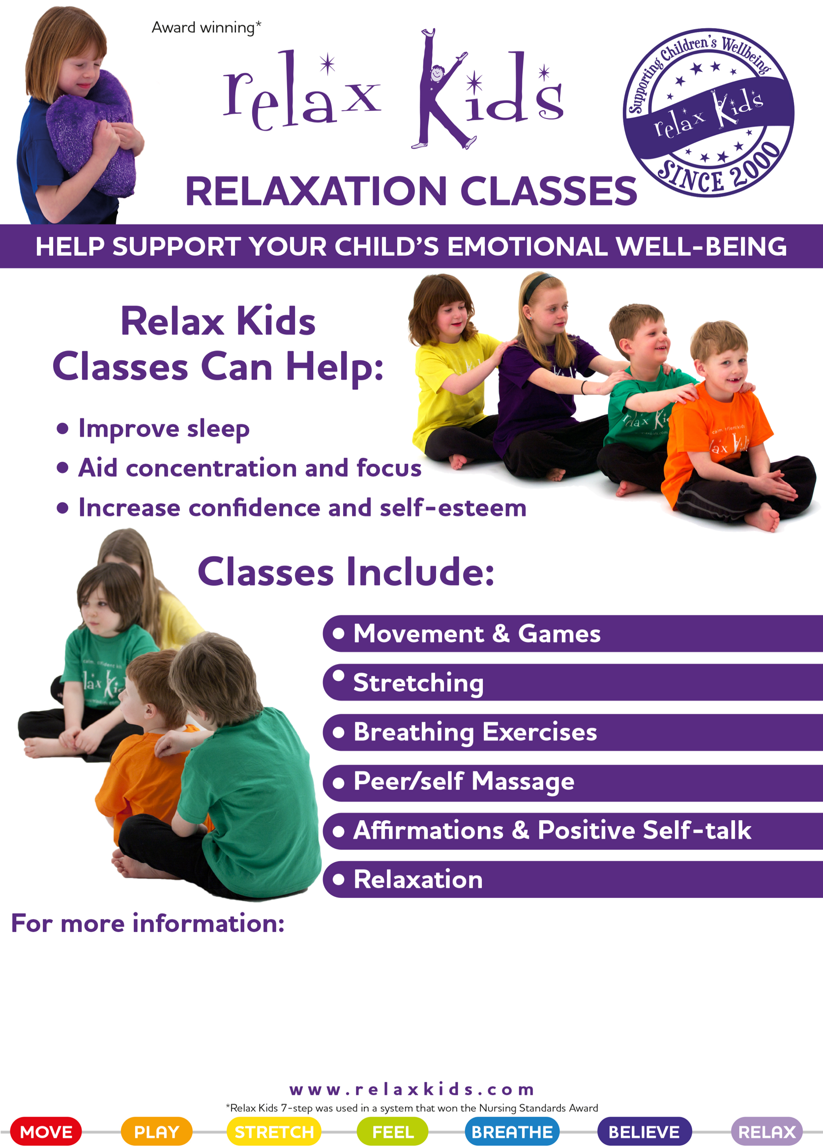
WEDNESDAYS 12.15 – 12.45pm KS1 (Year 1 & 2)
12.45 – 1.15pm KS2 (Year 3, 4, 5, 6)
£70 for x10 classes (Take home resources included and sibling discount available).
Email Katy relaxkidswithkaty@gmail.com to book a place (please specify which Year group).
Relax Kids aims to give children access to a variety of simple, yet effective techniques for relaxation, mindfulness and stress management that are developed and delivered in a fun and creative way.

