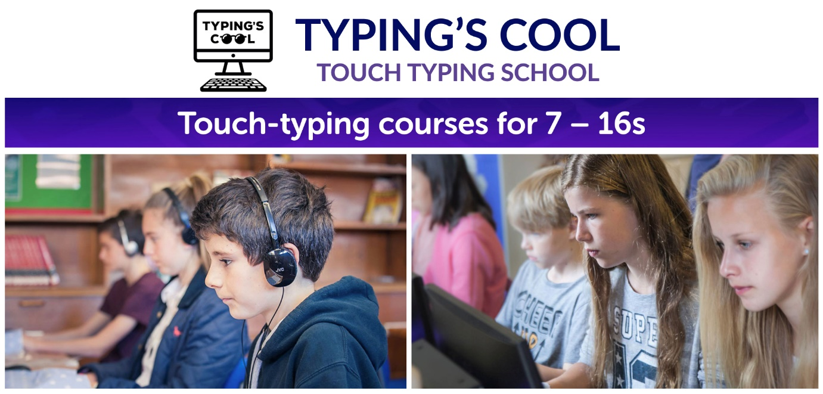
Advanced skills touch-typing club for Year 3 – 6
Monday 20 April – 29 June 2026; 8:00 – 8:45 am
Typing’s Cool teaches touch typing to 40+ words per minute with 95% accuracy. Using correct fingers and posture, muscle memory typing raises academic attainment.

Beginners, improvers and advanced typists are warmly welcome. We mix formal technique with the latest app games to make learning to type fast, fun and effective.

Flip flying skateboards, zap aliens and collect cool super hero movie outfits while learning an amazing skill. Typing proficiency significantly boosts your child’s academic attainment in today’s digital world.

Prior to setting up Typing’s Cool, Sarah Holt worked as a teacher at Weston Green School and Nick Holt was a secondary school Head of English. We are both passionate about helping all pupils fulfil their learning potential.

Club fee: £132.00 per term

Reduce the club fee by 25% using childcare vouchers or tax-free childcare. Contact us for more details.

To book a place use your school’s clubs sign up portal or email sarah.holt@typingscool.co.uk

