 | Autumn 1 | Autumn 2  Latchmere Art Curriculum Map 2025-2026 | Spring 1 | Spring 2 | Summer 1 | Summer 2
Nursery | Marvellous Me!  Drawing  David Zinn  To explore mark making using a range of drawing materials.  To investigate marks and patterns when drawing.  To identify similarities and differences between drawing tools.  To investigate how to make large and small movements with control when drawing. | Let’s Celebrate!  Drawing and painting – David Zinn  To create street art.  To use the skills they have learned to create street art. | Where do I live?  .Painting - Herve Tullet  Book - Press  To explore paint, using hands as a tool.  Describe colours and textures as they print.  To make natural painting tools.  To investigate natural materials.  To explore paint textures – mixing mud with water.  Respond to a range of stimuli when painting (music). | Animals  Painting – Herve Tullet  Book – Mix it  To explore what happens when paint colours mix. | What’s in the garden?  Sculpture and mixed media  Michelle Reader  Book – Clean Up  To explore the properties of clay.  To use modelling tools to cut and shape soft materials – dough, clay.  To select and arrange recycled materials to make 3D artworks.  To select and arrange natural materials to make 3D artworks. | Let’s have an adventure!  Sculpture and mixed media  Michelle Reader  Book – Grandad’s Island  To select and arrange recycled materials to make 3D artworks.  To select and arrange natural materials to make 3D artworks.  To combine malleable material and recycled materials to make 3D artworks.
Vocabulary | Straight, curvy, thick, thin, curved, zig-zag, squiggly  Street art, chalk, wax crayon, felt tip pen, chalk, rough, smooth |  | Press, figurative abstract, dot, fields, flowers, natural materials, mix, texture, pattern.  Music = happy, sad, excited, worried, fast, slow loud, quiet.  Colour mixing, colours, combine |  | Clay – pinch, roll, slimy, slippery, smooth, squash, sticky, stretch  Join, sculpture, fix, arrange, cut , glue, build, stick, bend, bumpy, plastic, wood, recycled materials.
Addressing misconceptions | Children think they can hold a mark making implement in one way rather than using the side of a crayon to make a mark, for example.  It is not acceptable to chalk on the ground. |  | Children think they cannot paint using natural materials as marking tools.  Music is not related to painting and emotions.  Children think they cannot combine colours to make a new colour. |  | Children think they cannot make something beautiful from ‘rubbish’ or recycled materials.
Assessment | Know that drawing tools make different marks.  Draw the marks modelled.  Note how they hold drawing tools. Model. |  | Identify and name the primary colours.  Know that two colours can be mixed to make a new colour (secondary colours) |  | Children can choose and combine resources to make a model.  Join materials together using scissors, tape and glue.  Start to talk about their model.
 | Colour, Value, line, Shape | Colour, Value, line, Shape | Colour, Value, line, Shape | Colour, Value, line, Shape | Form, Shape, Space, Texture | Form, Shape, Space, Texture
Reception  (order is flexible) | Drawing  Diane Alber  To know that closing lines make a shape.  To discuss different lines and patterns created on a variety of surfaces and with drawing tools.  To represent and draw different objects from memory and observation. |  | Painting  Herve Tullet (This builds on the learning from nursery)  To experiment with a range of painting tools such as thick/thin brush, fingers, spatulas, combs, toothbrush, cotton buds.  To mix primary colours to make secondary colours.  To mix white with red to make pink and white with black to make grey.  To experiment with printing using different objects.  To find different ways of printing (fruit/veg, sponges, lego, building blocks).  To create patterns using repeated shapes and overlapping shapes |  | Sculpture and mixed media  Andy Goldsworthy  To handle and investigate a variety of materials and malleable materials (boxes, pots, dough, lego)  To use hands to manipulate and arrange materials in different ways (rolling, kneading, pinching, stacking, lining up, gluing, enclosing)  To explore a range of materials (pasta, shells, rice, string, fabric, paper, card)  To create models using recycling materials.  To work with others to create a group or piece of work.  To experiment with a range of media to overlap and layer to create interesting colours, textures and effects.
Vocabulary | drawing, mark-making, lines, patterns |  | painting, print, artist, paint  thin/thick, wet, dry, dribble, splatter, drip.  pattern |  | sculpture, carving, modelling, stone, wood, clay, 3D  collage  texture
Addressing misconceptions | Children think they can’t write so they can’t draw.  If the drawing doesn’t look perfectly like the real object, they can’t draw. |  | Children believe they need to be good at drawing to paint |  | Not understanding what is meant by sculpture  Children don’t see their junk modelling as art
Assessment | Know that drawing tools make marks.  Name drawing tools including chalk, felt tips, pencils, crayons.  Draw different types of lines. |  | Know that paint can be applied in different ways. Can name different simple colours. Can use and/ or combine paint, collage and print to produce a work of art. |  | Knows that a 3D piece of artwork is known as sculpture. Have the experience of creating sculptures using a range of different materials. Cut shapes using scissors and other modelling tools and create own collages.
Year 1 | Drawing Line – making a mark  Bridget Riley  To know how to create different types of lines.  To explore line and mark-making to draw water.  To draw with different media.  To develop an understanding of mark making.  To apply an understanding of drawing materials and mark-making to draw from observation | 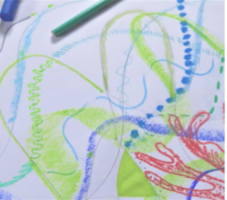 | Painting and mixed media Colour splash  Jasper Johns  To investigate how to mix secondary colours.  To apply knowledge of colour mixing when painting.  To explore colour when printing.  To experiment with paint mixing to make a range of secondary colours.  To apply their painting skills when working in the style of an artist. | 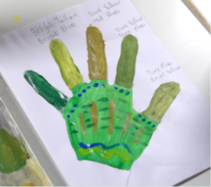 | Sculpture and 3D seaside collage, clay and paper play – Samantha Stephenson.  Anthony Gormly  To roll paper to create 3D structures.  To shape paper to create 3D drawing.  To apply paper shading techniques to make an imaginative sculpture.  To use my hands as a tool to shape clay. | 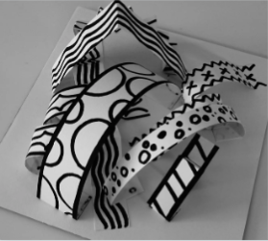
Vocabulary | 2D shape, 3D shape, abstract, chalk, charcoal, circle, continuous, cross, hatch, diagonal, dots, firmly, form, horizontal, lightly, line, mark making, narrative, observe, optical art, pastel, printing, shade, shadow, straight, texture, vertical, wavy |  | blend, hue, kaleidoscope, pattern, mix, primary colour, print, secondary colour, shade, shape, space, texture, thick |  | artist, carving, concertina, curve, cylinder, imagine, loop, mosaic, overlap, sculpture, spiral, three dimensional (3D), tube, zig-zag
Addressing misconceptions | A common misconception about line and mark making is that it's just about drawing lines or making random marks. In reality, mark making encompasses a wide range of techniques and is a powerful tool for expression, communication, and developing fine motor skills. It's not just about creating an image, but also about exploring materials, expressing emotions, and developing a personal style.  1. Line vs. Mark Making:  Misconception: Mark making is just another term for line drawing.  Reality: Mark making is a broader term that includes various techniques beyond simple lines, such as dots, dashes, hatching, cross-hatching, and scribbles. It's about exploring different ways to use a tool and create texture and pattern.  Reality: Lines are fundamental, but mark making is about the expressive potential of all marks, including those that don't conform to traditional line definitions. |  | A common misconception about secondary colours is that they can be created by mixing any two colours together. In reality, secondary colours (orange, green, and purple) are specifically made by combining equal parts of two primary colours (red, yellow, and blue). |  | A common misconception is that paper structures are inherently weak. While paper is often associated with fragility, it can be surprisingly strong when properly used and reinforced, especially when formed into cylindrical shapes. Another misconception is that paper is not a sustainable material, which is untrue as it's highly recyclable and renewable.
Assessment | Show knowledge of the language and literacy to describe lines.  Show control when using string and chalk to draw lines.  Experiment with a range of mark-making techniques, responding appropriately to music.  Colour neatly and carefully, featuring a range of different media and colours.  Apply a range of marks successfully to a drawing.  Produce a drawing that displays observational skill, experimenting with a range of lines and mark making.  FINAL PIECE – Bridget Riley |  | Name the primary colours.  Explore coloured materials to mix secondary colours.  Mix primary colours to make secondary colours.  Apply paint consistently to their printing materials to achieve a print.  Use a range of colours when printing.  Mix five different shades of a secondary colour.  Decorate their hands using a variety of patterns.  Mix secondary colours with confidence to paint a plate.  Describe their finished plates. |  | Roll paper tubes and attach them to a base securely.  Make choices about their sculpture, e.g. how they arrange the tubes on the base or the colours they place next to each other.  Shape paper strips in a variety of ways to make 3D drawings.  Glue their strips to a base in an interesting arrangement, overlapping some strips to add interest.  Create a tree of life sculpture that includes several different techniques for shaping paper.  Work successfully with others, sustaining effort over a time.  Paint with good technique, ensuring good coverage.
Key concepts | - Colour, Value, line, Shape |  | Shape, Value, Line |  | Form, Shape, Space, Texture
Year 2 | Drawing – Telling a story  Quentin Blake  To develop a range of mark making techniques.  To experiment with mark making to create texture.  To develop observational drawing.  To understand how to apply expressions to illustrate a character.  To develop illustration to create a story. | 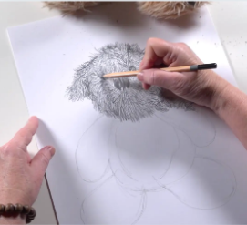 | Painting and mixed media – Life in colour – Amy Sherald (25/26)  To develop knowledge of colour mixing.  To know how texture can be created with paint.  To use paint to explore texture and pattern.  To compose a collage, choosing and arranging materials for effect.  To evaluate and improve artwork. | 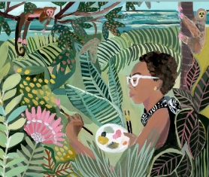 | Sculpture – 3D clay houses  Ranti Bam, Rachel Whiteread  To use my hands as a tool to shape clay.  To shape a pinch pot and join clay shapes as decoration.  To use impressing and joining techniques to decorate a clay tile.  To use drawing to plan the features of a 3D model.  To make a 3D clay tile from a drawn design. | 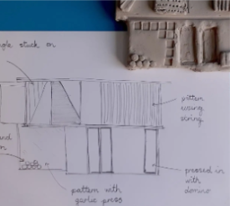
Vocabulary | blending, charcoal, concertina, cross hatching, emoji, emotion, expression, frame, hatching, illustrations, illustrator, lines, mark making, re-tell, scribbling, sketch, stippling, storyboard, texture, thick, thin |  | collage, detail, mixing, overlap  primary colour, secondary colour, surface, texture |  | casting, ceramic, cut, detail, flatten, glaze, impressing, in relief, join, negative space, pinch pot, plaster, roll, score, sculptor, sculpture, shape, slip, smooth, surface, three, dimensional, thumb pot
Addressing misconceptions | Children believing mistakes are a sign of failure.  Additionally, some believe drawing relies solely on imagination, when it also involves observation, construction, and understanding of techniques. |  | A common misconception about colour mixing is that all colours can be created from a single set of three primary colours (red, yellow, and blue). |  | Clay is messy and difficult:  Clay can be messy, but it's a rewarding material to work with. It requires understanding its properties and handling techniques, but it's not inherently difficult.
Assessment | Know that rubber can be used to refine lines but also lighten shaded areas.  Know that tones can be blended together from light, mid to dark using a pencil and charcoal.  Can create texture by frottage, rubbings and lines.  Know how to use charcoal and look after it. |  | Name the primary and secondary colours.  Talk about the colour changes they notice and make predictions about what will happen when two colours mix.  Describe the colours and textures they see.  Try different tools to recreate a texture and decide which tool works best.  Show they can identify different textures in a collaged artwork.  Apply their knowledge of colour mixing to match colours effectively.  Choose collage materials based on colour and texture.  Talk about their ideas for an overall collage.  Try different arrangements of materials, including overlapping shapes.  Give likes and dislikes about their work and others’.  Describe ideas for developing their collages.  Choose materials and tools after trying them out.  FINAL PIECE – Amy Sherald |  | Flatten and smooth their clay, rolling shapes successfully and making a range of marks in their clay.  Make a basic pinch pot and join at least one clay shape onto the side using the scoring and slipping technique.  Roll a smooth tile surface.  Join clay shapes and make marks in the tile surface to create a pattern.  Draw a house design and plan how to create the key features in clay.  Create a clay house tile that has recognisable features made by both impressing objects into the surface and by joining simple shapes.
Key Concepts | Shape, Value, Line, Space. |  | Colour, Value, Shape, Texture |  | Form, Shape, Space, Texture
Prior Knowledge assemblies for Yr3/4 | Art movements – pop art, impressionism, realism, surrealism | 10 art pieces you should know and recognise | Art movements – neoclassicism, cubism, renaissance, expressionism |  | Expressing opinions about art, the difference between like and appreciate
Year 3 | Cave paintings  To apply an understanding of prehistoric man-made art.  To understand and use scale to enlarge drawings in a different medium.  To explore how natural products produce pigments to make different colours.  To select and apply a range of painting techniques.  To apply painting skills when creating an artwork.  Frida Khalo – Day. | 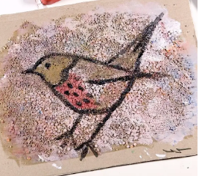 | Craft and design – Egyptian art and scrolls  To investigate the style, pattern and characteristics of Ancient Egyptian art  To apply design skills inspired by the style of an ancient civilisation.  To apply understanding of ancient techniques to construct a new material.  To apply drawing and painting skills in the style of an ancient civilisation. | 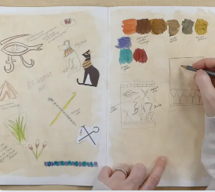 | Drawing – Growing artists (Georgia O Keefe)  Artist study and artist response page  To recognise how artists use shape in drawing.  To understand how to create tone in drawing by shading.  To understand how texture can be created and used to make art.  To apply observational drawing skills to create detailed studies.  To apply an understanding of composition to create abstract drawings. | 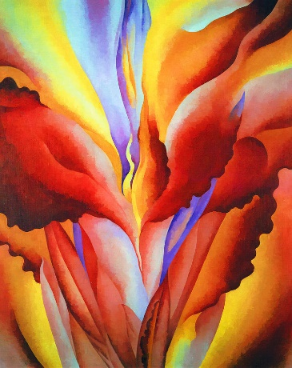
Vocabulary | charcoal, composition, negative image, pigment, positive image,  Prehistoric, proportion, scaled up, sketch, smudging, texture, tone |  | ancient, audience, civilisation, colour, composition, convey, design, Egyptian, fold, imagery, inform, layout, material, painting, papyrus, pattern, process, scale, scroll, sculpture, shape, technique |  | abstract, arrangement, blend, botanical, botanist, composition, cut, dark, even, expressive, form, frame, frottage, geometric, gestural, grip, light, line, magnified, organic, object, pressure, rubbing, scale, scientific, shading, shape, smooth, surface, tear, texture, tone, tool, viewfinder
Addressing misconceptions | There are examples of elaborate cave paintings from early civilisations. Also look at early Islam art examples.  Misconception: Cave paintings were created solely for decoration.  In reality, cave art likely had spiritual, ritualistic, or communicative purposes, not just decorative.  Misconception: Prehistoric people were primitive and lacked artistic skill.  Emphasize the sophistication of prehistoric art techniques.  Misconception: All prehistoric art looks the same.  Students may assume uniformity in style and meaning, whereas different regions and periods produced diverse imagery.  Misconception: All pigments produce vibrant colours.  Students might expect modern paint-like vibrancy, while prehistoric pigments tended to be earthy, muted tones. |  | A range of sophisticated materials were used in Egyptian art. Gold came from the River Nile.  Misconception: Egyptian art was only flat and two-dimensional.  While 2D art is most familiar, Egypt also produced sophisticated 3D art (e.g., statues)  Misconception: Ancient Egyptian art was purely decorative.  Students might not realize that Egyptian art was highly symbolic and served religious, political, or funerary functions.  Misconceptions: Ancient Egyptian artists had full creative freedom.  Egyptian art was bound by strict conventions and rules based on social roles, not personal expression.  Misconception: Design skills in the Egyptian style are the same as modern design.  Ancient Egyptian design prioritized symbolism and order over realism and expression, unlike many modern design philosophies. |  | That O’Keeffe was only known for botanical drawings. She also painted American landscapes.  Misconception: Abstract means messy or random.  Students may think abstract drawing doesn’t require skill or planning, when in fact O'Keeffe’s abstractions are carefully composed.  Misconception: Shading only makes things look 3D.  While shading can create form, students might overlook its role in suggesting mood, texture, or depth without realistic rendering.  Misconception: Observation means copying exactly.  Observational drawing is about close looking and interpretation, not just photorealistic reproduction.
Assessment  Pupils who are secure will be able to: | Recognise the processes involved in creating prehistoric art.  Explain approximately how many years ago prehistoric art was produced.  Use simple shapes to build initial sketches.  Create a large scale copy of a small sketch.  Use charcoal to recreate the style of cave artists.  Demonstrate good understanding of colour mixing with natural pigments.  Discuss the differences between prehistoric and modern paint.  Make choices about equipment or paint to recreate features of prehistoric art, experimenting with colours and textures.  Successfully make positive and negative handprints in a range of colours.  Apply their knowledge of colour mixing to make natural colours. |  | Recognise and discuss the importance of Ancient Egyptian art.  Consider the suitability of a surface for drawing.  Record colours, patterns and shapes through observational drawing.  Choose and use tools and materials confidently.  Begin to experiment with drawing techniques.  Create a selection of sketches that show idea exploration.  Produce a final design with a clear purpose.  Follow instructions with minimal support.  Discuss and evaluate the process and outcome of their work.  Produce a complete painted or drawn piece from a design idea.  Use colours and materials appropriately, showing an understanding of effective composition.  Have a clear idea of the subject of their zine, including a range of images and information. |  | Know the difference between organic and geometric shapes.  Use simple shapes to form the basis of a detailed drawing.  Use shading to demonstrate a sense of light and dark in their work.  Shade with a reasonable degree of accuracy and skill.  Blend tones smoothly and follow the four shading rules.  Collect a varied range of textures using frottage.  Use tools competently, being willing to experiment.  Generate ideas mostly independently and make decisions to compose an interesting frottage image.  Make considered cuts and tears to create their ideas.  Understand how to apply tone, with some guidance about where to use it.  Draw a framed selection of an image onto a large scale with some guidance.  Try a range of drawing materials, to demonstrate expressive marks by trying tools in an interesting way.
Key Concepts | Colour, Value, Shape, Texture |  | Shape, Value, Line, Space | . | Form, Shape, Space, Texture
Year 4  Pupils who are secure will be able to: | Drawing – Power prints (Matisse)  To draw using tone to create a 3D effect.  To explore proportion and tone when drawing.  To plan a composition for a mixed-media drawing.  To use shading techniques to create pattern and contrast.  To work collaboratively to develop drawings into prints | 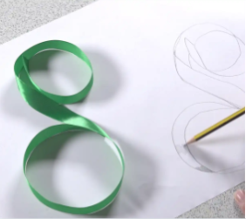 | Painting and mixed media - Paul Cezanne  To investigate ways of applying paint. To mix tints and shades of a colour.  To use tints and shades to give a three-dimensional effect when painting.  To explore how paint can create very different effects.  To consider proportion and composition.  To apply knowledge of colour mixing and painting techniques to create a finished product. | 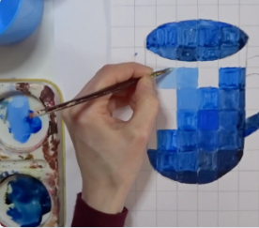 | Sculpture and 3D Mega materials  Barbara Hepworth To develop ideas for 3D work through drawing and visualisation in 2D.  To use more complex techniques to shape materials.  To explore how shapes can be formed and joined in wire.  To consider the effect of how sculpture is displayed.  To choose and join a variety of materials to make sculpture. | 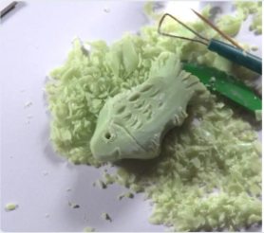
Vocabulary | abstract, block print, collaborate, collaboratively, collage, combine, composition, contrast, cross-hatching,  figurative, gradient, hatching, highlight, mixed media, monoprint, observational drawing, parallel, pattern, precision, printmaking, proportion, shading, shadow, symmetry, three dimensional (3D), tone, viewfinder, wax-resist |  | composition, hue, proportion, shade, shadow, still life, tint, tone |  | ceramics, form, found objects, organic shape, scale, sculpture, typography, optical illusion
Addressing misconceptions | A common misconception about tone and shading is that they are solely about making areas darker or lighter. In reality, tone and shading are fundamental to creating depth, form, and mood in art, and involve a range of values from pure white to deepest black, including mid-tones. |  | A common misconception about tint and shade in painting is that they are used interchangeably. Tints are created by adding white to a colour, resulting in a lighter version, while shades are created by adding black, making the colour darker. Adding grey to a colour creates a tone, which desaturates the original hue. |  | A key misconception about Barbara Hepworth is that her work is cold, austere, and unemotional, or that it's a less serious or less expensive alternative to Henry Moore's.
Assessment | Create several pencil tones when shading and create a simple 3D effect.  Explore the effect of holding a pencil in different ways and applying different pressures.  Use charcoal and rubber to show areas of light and dark in their drawings.  Demonstrate an awareness of the relative size of the objects they draw.  Use scissors with care and purpose to cut out images.  Try out multiple arrangements of cut images to decide on their composition.  Use different tools to create marks and patterns when scratching into a painted surface.  Show some awareness of how to create contrast by including areas with more and less marks.  Create an interesting finished drawing based on their original composition, including detail such as contrast and pattern.  Work co-operatively to create a joint artwork, experimenting with their methods. |  | Explain what tints, shades and tones are. Combine these to create 2D effect.  Understand proportion and create still life art.  Knows different painting techniques such as pointillism, dabbing and washing.  FINAL PIECE – CEZANNE STILL LIFE |  | Explain how to use tools safely to create wire sculptures.  Explores the way different materials can be shaped and joined.  Learn about techniques used by artists such as El Anatsui and Sokari Douglas-Camp.  Create own sculptures with wire and paper.
Key Concepts | Colour, Value, Shape, Texture |  | Shape, Value, Line, Space |  | Form, Shape, Space, Texture
Year 5  Pupils who are secure will be able to: | Drawing – William Morris – Paul Klee, Leonardo Da Vinci  To develop drawings from observation.  To understand and explore decision making in creative processes.  To develop drawn ideas through printmaking.  To test and develop ideas using sketchbooks.  To apply understanding of drawing processes to revisit and improve ideas. | 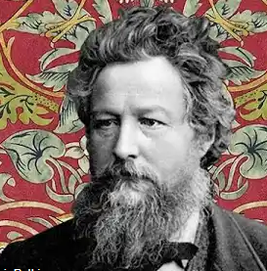 | Painting and mixed media – Cityscapes – L.S. Lowry  To identify and discuss the works of L.S Lowry.  To explore how a drawing can be developed.  To develop skills in sketching using perspective.  To explore techniques and style used by LS Lowry.  To understand the use of colour.  To apply painting techniques to create an artwork inspired L.S Lowry. | 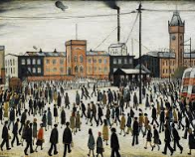 | Craft and design architecture -  Gaudi  To apply observational drawing skills to interpret forms accurately.  To apply composition skills to develop a drawing into print.  To apply an understanding of architecture to design a building.  To extend design ideas through research and sketchbook use.  To explore and evaluate the intention of a design. | 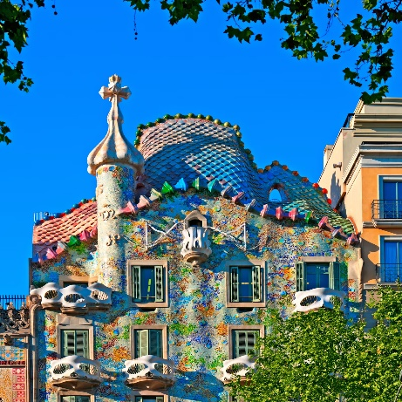
Vocabulary | organic and irregular lines, graduation, tone, shading, continuous line, monochromatic, symmetrical, asymmetrical, repeat, pattern, negative space, Arts and Crafts Movement, cross-hatching, blending, stippling.  collagraph, collagraphy, composition, culture, decision, develop, evaluate, printing plate, printmaking, |  | Industrial, landscape, foreground, mid-ground, background, perspective, tone, contrast, complementary, brush stroke, palette, social commentary, matchstick figure |  | abstract, annotate, architect, architectural, architecture, birds eye view, built environment, commemorate, composition, crop, design, design brief, design intention, elevation, evaluate, external, form, futuristic, individuality, interpret, legacy, literal, monoprint, monument, observational drawing, organic, perspective, pressure, proportion, style, symbolism, viewfinder
Addressing misconceptions | A common misconception about William Morris is that he was solely a designer focused on beautiful objects for the wealthy, detached from the realities of industrial society. In reality, Morris was a complex figure who was both a successful businessman and a socialist. He believed in the unity of art and life, advocating for craftsmanship and the revival of traditional techniques. |  | A common misconception about L.S. Lowry is that he was a naive, untrained artist. While his style is distinctive and often described as simple, he actually studied art for many years, including life drawing. Another misconception is that he only painted industrial landscapes with "matchstick men". While these scenes are iconic, Lowry also painted portraits, seascapes, and other subjects, and his work goes beyond simple depictions of industrial life. |  | A common misconception about Antoni Gaudí is that his eccentric style was a result of a disordered mind or a lack of formal training. In reality, Gaudí was a highly intelligent and skilled architect who meticulously planned his designs, drawing inspiration from nature and incorporating complex mathematical and structural principles.
Assessment | Participate in discussions and offer ideas.  Evaluate images using simple responses, sometimes using formal elements to extend ideas.  Provide plausible suggestions for how a piece was created.  Comfortably use different stimuli to draw from.  Use past knowledge and experience to explore a range of drawing processes.  Select and place textures to create a collagraph plate, applying an understanding of the material, which may be supported by testing.  Create a selection of drawings and visual notes that demonstrate their ideas using sketchbooks.  Generate a clear composition idea for a final piece.  Apply confident skills to make an effective collagraph print.  Independently select tools and drawing techniques, with some guidance.  Demonstrate growing independence, discussing ways to improve work.  FINAL PIECE – William Morris Print |  | Try a variety of materials and compositions for the backgrounds of their drawings.  Show that they are making decisions about the position of a drawing on their background, trying multiple ideas.  Create a successful print.  Use art vocabulary to talk about and compare portraits.  Identify key facts.  Explain their opinion of an artwork.  Experiment with materials and techniques  Create a painting that’s inspired by an artist.  Show they have considered the effect created by their choice of materials and techniques and composition in their final piece. |  | Sketch a house from first-hand or second-hand observation.  Use basic shapes to place key features and form the composition, measuring to work out proportions.  Notice small details to incorporate into the drawing by observing.  Select a section of their drawing that creates an interesting composition, with a variety of patterns, lines and texture.  Follow steps to create a print with clear lines, with some smudging.  Purposefully evaluate their work, demonstrating what went well and what could be improved.  Create a building design based on a theme or set purpose.  Draw a plan view or front elevation of their building, annotating the key features.
Key concepts | Colour, Value, Shape, Texture |  |  | Form, Shape, Space, Texture |  | Shape, Value, Line, Space
Year 6  Pupils who are secure will be able to: | Drawing – Make my voice heard  Diego Rivera, and Mayan Art  To understand the qualities if different drawing media and evaluate their effectiveness for different tasks.  To understand the proportion of faces and how to use the grid method to draw accurately. | 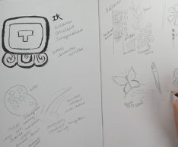 | Painting and mixed media  David Hockney  To understand how to analyse a famous painting.  To understand how to find meaning in a painting.  To apply interpretation skills to analyse and respond to an abstract painting.  To understand how art can tell stories or portray images.  To develop starting points for creative outcomes. | 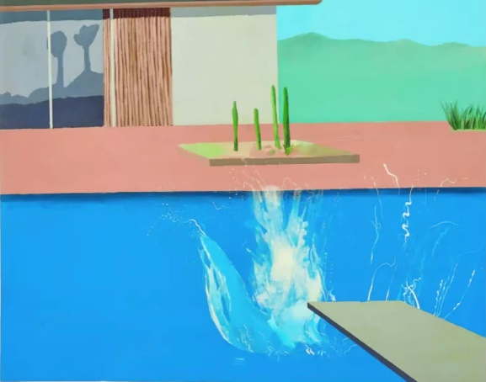 | Sculpture and 3D: Making memories – Yayoi Kusama  Mini lesson – artist knowledge  Artist response page  Sketch starter page  Explode a picture  Explore sculpture techniques  Me in a Kusama box – planning for 3D sculpture  Apply understanding of abstract art and make design choices for effect | 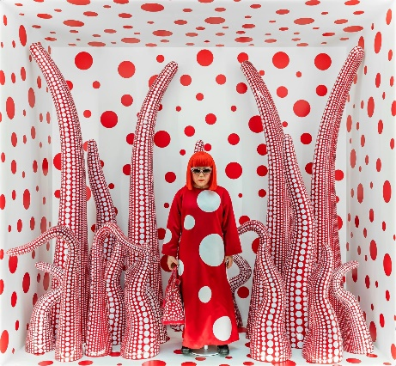OUTCOME PIECE  Produce a 3D box with a polka dot background with a clay sculpture piece and a figurine of self.
Vocabulary | abstract, chiaroscuro, composition, figurative, parallel lines, symbolism, literal, symbolic |  | abstract, analyse, evaluate, interpret, medium, mixed-media, narrative, respond, tableau |  | arrangement, digital, layout, macro, monochrome, photography, photomontage, photorealism, prop, saturation
Addressing misconceptions | Drawing faces, like any skill, requires practice, observation, and understanding of underlying anatomy and perspective. Another misconception is that you should avoid using reference photos, but most professional artists rely on them. Additionally, some believe that drawing faces over a certain age requires adding wrinkles and grey hair, which is not always accurate. |  | A common misconception about abstract painting is that it's just random or meaningless, requiring no skill or technique. In reality, abstract art involves a deep understanding of visual language, composition, colour theory, and various artistic techniques. |  | A common misconception about clay is that air bubbles will cause explosions during firing, but it's actually moisture trapped inside the clay that leads to this. Another misconception is that clay is messy and difficult to handle, while it's a versatile material that can be reused and recycled.
Assessment | Know that, when drawing from observation, they must consistently look at the subject to gauge accurate shape, form, tone and proportion.  Confidently know what pencil to use to create texture, light and contour.  Use different resources to draw, create texture and composition. |  | Can develop their techniques, including their control and use of materials, with creativity, experimentation and an increasing awareness of different kinds of art, craft and design.  Have a good understanding of colour and will be able to find complimentary, contrasting and analogue colours. |  | Can develop photography skills and techniques to design a range of creative photographic outcomes.  Create photomontage, macrophotography by recreating photorealistic portraits.  Begin to understand and apply editing techniques.
Key Concepts | Shape, Value, Line, Space. | Colour, Value, Shape |  |  | Form, Shape, Space, Texture

