Nursery Summer Term 2026
Area of learning | Objectives/skills | Revisit/ongoing through year
Area of learning | Objectives/skills | Revisit/ongoing through year | Suggested texts, songs and rhymes
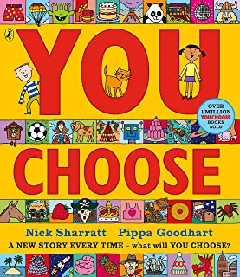  Communication and Language | Listening, attention and understanding:  Listening to longer stories and remember most of what happens.  Pay attention to more than one thing at a time. Listen to a friend while drawing a picture.  Understand ‘why’ questions, such as: Why did the fairy feel sad when Freddie asked her a question?  Understand a question or instruction that has two or more parts, such as: “Get your coat and bag and wait at the door.”  Speaking:  Speak in sentences of four to six words using a wider vocabulary. Start a conversation and continue it for many turns.  Join sentences up with words like ‘because’, ‘or’, ‘and’. For example, ‘I like ice cream because it is tasty.  Start to use the future and past tense – ‘I am going to my nan’s house.’ ‘I went to the seaside.’  Use talk to organise themselves and their play, “Let’s go shopping. You get the bags, I’ll drive the car.”  Sing more songs and rhymes. Talk about familiar books. | Learn new vocabulary. Use new vocabulary in different contexts and revisit over time.  Use new vocabulary through the day in discussions, conversations and different contexts. Revisit over time.  Learn new rhymes, poems, and songs.  Listen to and talk about stories to build familiarity and understanding. | 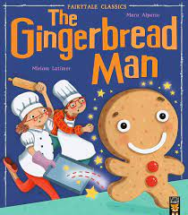  Revisit our ‘inside out’ books:  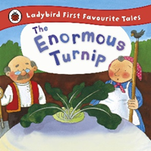  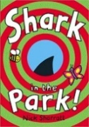  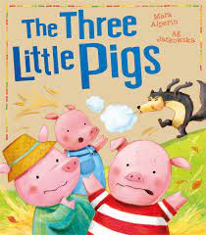
Personal, Social  and Emotional Development  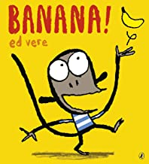 | Express feelings:  Use words such as ‘happy’, ‘sad’, ‘angry’ and ‘worried’ using the ‘zones of regulation’ and our ‘feelings’ dial to describe how we feel and how others feel in stories and when we are playing.  Learn ways of ‘calming’ ourselves if we feel angry or upset – Rainbow breathing, counting to 10, looking at books - toolkits.  Manage behaviour:  Demonstrate appropriate ways of being assertive by using our words - “Stop. I don’t like that.”  Use our words to solve conflicts with others. ‘Please can I ride the bike now? I will give you another turn.’ Timers.  Self-awareness: respectful, responsible, reflective  Review 3 school rules. Increasingly follow and remember rules and understand why they are important.  Notice and ask questions about differences, such as skin colour, hair, gender, special needs and disabilities, religion.  Talk about the different languages we speak and say ‘hello’ in those languages at ‘hello time’.  Independence:  Be increasingly independent in dressing, using the toilet, washing and drying hands and brushing their teeth.  Make healthy choices about food, drink and tooth brushing.  Collaboration:  Develop their sense of responsibility and membership of a community. For example, putting resources away where they belong, helping friends to build in a group situation, sweeping and cleaning the tables after snack time.  Social skills:  Play with one or more other children, extending and elaborating play ideas.  Learn to take turns. Understand that we can have more than one friend and working out roles for each person in the game, finding solutions to conflicts and rivalries. Become more outgoing with unfamiliar people. | Recognising, identifying, naming and talking about feelings using gesture, visuals and words.  Refer to class rules and expectations and feelings in meaningful situations during play and stories.  Zones of regulation  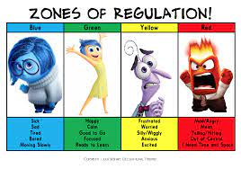  4 zones:  Green – happy, calm  Blue – sad, upset  Yellow – worried  Red - angry  Use Makaton signs to support understanding.  Use ‘feelings friends’ to support emotions.  Daily emotion check-in | 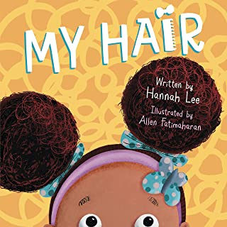  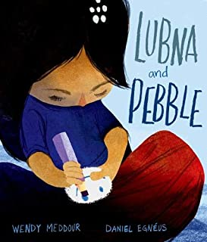  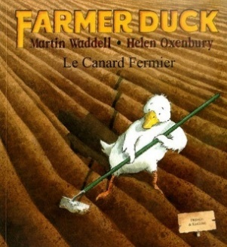  These are some of the texts we will share with the children:  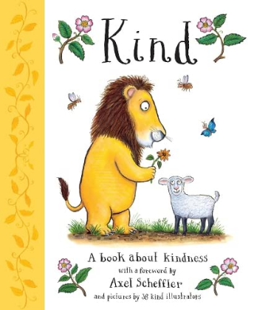
Physical  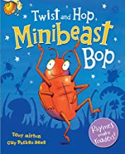  Development | Gross motor skills:  Kick, throw and catch balls through small group/paired games – balls in buckets, throwing and catching games.  Continue to develop their movement skills – roll, crawl, jump, run, hop, climb, gallop….and respond to instructions.  Balance ride and pedal on tricycles.  Copy and remember sequences and patterns of movement which are related to music and rhythm.  Learn to run fast and in a straight line, to jump hurdles and to negotiate an obstacle course.  KAPOW – Ball skills – Unit 1. Games – Unit 1. Participate in sports week and sports day activities to demonstrate skills.  Fine motor skills:  Use different materials and one-handed tools and equipment - use playdough tools, cutlery, sand tools.  Use scissors to cut along straight and curved lines. Use both hands for cutting, threading, using bats and balls.  Learn to control mark making tools to draw circles, both clock-wise and anti-clockwise and lines and other shapes. | Continue to develop overall body-strength, balance, co-ordination, and agility through use of outdoor play equipment.  Regular visits to the leisure area to develop climbing and balancing skills and to improve strength.  Regular opportunities to run and get out of breath.  Opportunities for OT sessions: trampoline, balance boards, swing chair, giant cone, trikes and bikes. | Circle games outside:  What’s the time Mr Wolf?  Duck, duck, goose.  The Farmers in his den  Other games:  Shark attack  Traffic Lights  Jumping Beans
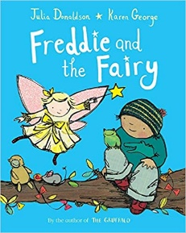  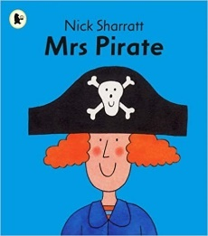  Literacy | COMPREHENSION  Engage in extended conversations about stories, learning new vocabulary.  Engage in play scenarios around stories using props and the environment. For example,  Understand the five key concepts about print:  Print has meaning. Print can have different purposes. For example, looking at print on different cereal packets, signs, instructions.  We read English from left to right and from top to bottom. Model this while sharing books. | Daily singing, story reading, telling and acting.  Adults modelling book handling skills.  ‘inside out’ story focus to increase comprehension of stories and embed new vocabulary.  Re-read books to build up their understanding and enjoyment of them and to create a memory of them. | These are some of the texts we will share with the children:  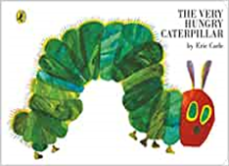  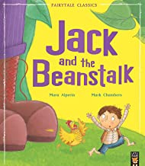  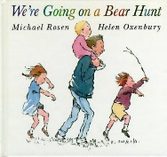
 | WORD READING  Notice some print, such as their name or print in the nursery, on food packaging or a familiar logo.  Recognise their friends’ names on the ‘Who’s here today?’ board. | Refer to children’s names on the Rainbow board daily to support recognition.
 | WRITING  Compose a story sentence to describe their picture. Retell parts of a story to be scribed by an adult.  Make group stories or songs based on a known one – Old MacDonald had a zoo.  Use some of their early print knowledge in their early writing – write letters and marks to represent their name, or ‘m’ for mum, for example.  Write the first letter or some letters of their name.  Handwriting:  Learn the language of direction – up, around, down, back when tracing or drawing patterns.  Trace and copy large handwriting patterns.  Form the first two letters of their name accurately using ‘Little Wandle’ letter formation. Make the letter shapes large in the air. | Encourage children to tell ‘stories’ about what they have been doing.  Core strength and fine motor experiences to develop readiness for mark making and writing.
Phonics | Phase 1 – Little Wandle Foundations  Join in with songs and rhymes, copying sounds  Hear rhymes, clap the syllables in their names and ‘wonderful words’ – use a drum with a beater or claves.  Recognise words with the same initial sounds through playing games such as ‘What’s in the box?’, ‘Cross the River’ or ‘Silly Soup’.  Start to blend sounds together to make simple words – ‘s-u-n’ is ‘sun’. ‘Can you touch your n-o-se?’ ‘Remember your b-a-g.’ | Develop general sound discrimination and rhythm and rhyme through daily singing, rhyming and phase 1 phonic games.
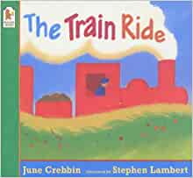  Mathematics | Number  Subitise- Develop fast recognition of up to 3 objects, without having to count them individually. Play active sorting card games.  With each number, ‘What can we see? How can we see it? I can see 3. ‘ I can see 2 and 1’ or ‘1 and 1 and 1’  Say one number for each item in order: 1,2,3,4,5. Recite numbers past 5 when playing games. Show finger numbers to 5.  Begin to realise that the last number reached when counting a small set of objects tells you how many there are in total (cardinal).  Link numerals and amounts: Identify the numeral and count out the correct number of frogs into the pond, for example.  Use language such as ‘more than’ and ‘fewer than’ in everyday situations to compare quantities. “Sally has fewer jewels than David.”  Write marks or numerals to represent how many there are.  Solve real world mathematical problems with numbers up to 5 – ‘There are 4 teddies but not enough chairs. What can we do?’ | Opportunities for maths through routines:  Complete the daily calendar.  Explore positional language through stories, such as ‘Going on a Bear Hunt’.  Refer to ‘2 apples’, ‘3 chairs’. “Can you pass me the 3 cars, please?”  Use 5 frames at snack time to ‘see’ “3 apples and 2 spaces.”  Talk about ‘full 5 frames’ when looking at children’s photos on 5 frames.  Number rhymes and songs:  Days of the week song  5 Little Ducks  5 Little Speckled frogs  I am a greedy crocodile  1 elephant went out to play…  1 Little Blue fish swimming in the water | 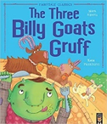  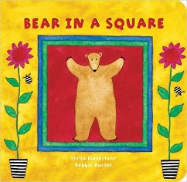  These are some of the texts we will share with the children:  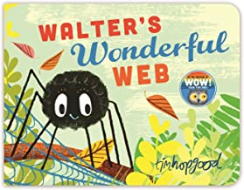  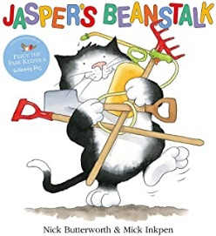
Shape, Space and Measures:
Use positional language when acting out stories – “The troll lives under the bridge.”
Use words such as ‘in front of’, ‘behind’, turn right, next to when lining up or describing journeys to different parts of the school.

Compare sizes, weights etc. using gesture and language – bigger/little/smaller, high/low, tall, heavy.
Notice patterns and arrange things in patterns – stick, leaf, stick, leaf.
Notice and correct an error in a repeating pattern.
Talk about and explore 2D and 3D shapes (circles, rectangles, triangles, cuboids) using informal and mathematical language: pointy, curvy, sides, corners, straight, flat, round, while building.
Use ‘first’, ‘next’, ‘then’, ‘after’, ‘before’, ‘morning’, ‘afternoon’, ‘yesterday’, ‘tomorrow’ – to sequence events and talk about time.
Sharing ‘mathematical’ stories to learn mathematical language and to deepen an understanding of concepts.
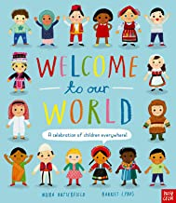  Understanding the World | Introduce new vocabulary related to explorations and investigations.  People, culture and communities  Continue developing positive attitudes about the differences between people through sharing stories and finding out which countries our families live in and which languages they speak. Find places on the world map.  Know that there are different countries in the world and talk about the differences children have seen in photos or experienced through places visited on holiday or when visiting family. Find places on the world map linked to holidays, Latchmere Goes Global and stories. Linking our ‘adventures’ to other environments, such as under the sea.  Past and Present  Begin to make sense of their own life-story and family’s history through reflecting on photos of their families and of themselves as babies – ‘Then I could…..Now I can…..’  Show interest in everyday ‘mystery objects’. I wonder what it is? What could it be used for? Who would use it?  The Natural World  Name and describe the flowers in the nursery garden and in the school grounds.  Plant seeds and care for plants – plant beans, cress and other seeds linked to ‘Jack and the Beanstalk’ and ‘Jasper’s Beanstalk’.  Respect and care for the natural environment and all living things through observing and caring for plants and creatures.  Understand the key features of life-cycles through observing and caring for caterpillars and plants.  Name minibeasts and the parts of an insect’s body.  Notice and talk about changes in materials, for example, notice and talk about what happens when you pick up cornflour or when ice is heated or water is put in the freezer..  Explore and talk about the different forces they feel. For example, during water play, talk about how water pushes up when foam is pressed down on it. Explore stretchy toys and talk about what happens when building with magnetic toys. | Observation and Communication:  Observe, notice and talk about what happens to the trees in the nursery garden and around the school as the seasons change.  Share, celebrate and talk about children’s festivals and special celebrations through the year, including the arrival of new babies, VE Day. | 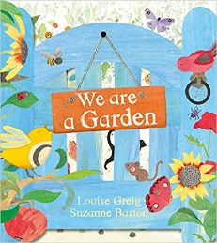  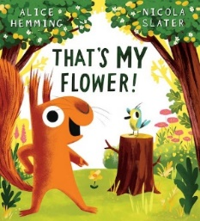  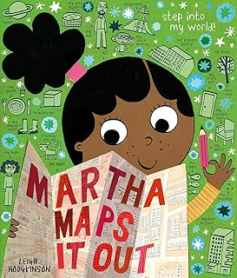  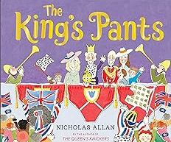  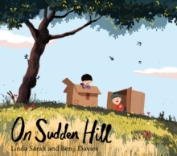
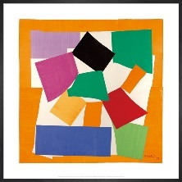  Expressive Arts and Design | In the workshop, creative area and outside:  Focus Artist: Michelle Reader  Unit – Sculpture and 3D – Reusing waste materials to create unique, figurative sculptures.  - Exploring the qualities of clay  - The importance of recycling for the environment.  - Use recycled and found materials to make an animal home.  - Collect natural materials and create an island.  - Create farm animal or imaginary animal sculptures.  Develop their own ideas and then decide which materials to use to express them. Scrunching techniques for flowers.  Join different materials - adults provide paper clips, split pins, cardboard boxes and teach the skills of joining and attaching.  Experiment with colour mixing – limit paint to primary colours to encourage colour mixing. Stimulus – Herve Tullet – ‘Mix it Up’. Children mix primary colours in ziplock bags and by painting on both hands, then mixing and creating hand prints.  Draw with increasing complexity and detail. For example, draw flowers and minibeasts using reference books or real flowers/minibeasts. Look closely and draw what they see.  Show different emotions in their drawings – happiness, sadness, worry, anger – link to ‘zones of regulation’ and to how we feel about our experiences of going on holiday, being with friends, feeling worried about new experiences.  Explore a range of sound makers and instruments and play them in different ways.  Listen with increased attention to sounds. Listen while painting or drawing.  Develop complex stories using small world equipment such as animal sets, blocks and construction using their own ideas. Provide a range of resources.  Sing the melodic shape of a song (without using the words).  Respond to what they have heard, expressing their thoughts and feelings. Listen to music linked to the cultures we come from.  Remember and sing entire songs. | Teaching skills of cutting, joining and using materials, tools and equipment in the ‘workshop area’, at the ‘Tinkering Table’ and in the ‘creative area’.  Daily group singing of nursery rhymes and songs, revisiting the same ones to commit them to memory.  Explore and engage in music making and dance, performing solo or in groups.  Perform our class assembly | 