Inside out stories and nursery rhymes in Rainbow Nursery
These are the stories and nursery rhymes that we would like children to know ‘inside out’ by the time they leave nursery. Please read the stories with your child, talk about the pictures, use the ‘wonderful words’ in other situations and recite nursery rhymes all the time. Enjoy learning together!
Autumn 1  Marvellous Me! | Autumn 2  Let’s Celebrate! | Spring 1  Where do I live? | Spring 2  Animals | Summer 1  What’s in the Garden? | Summer 2  Going on an adventure!
The Enormous Turnip  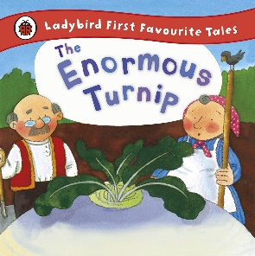 | 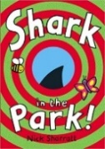  Shark in the Park | Three Little Pigs  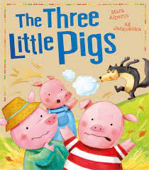 | 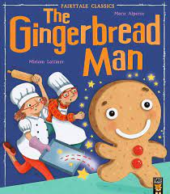  The Gingerbread Man | 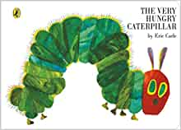  The Very Hungry Caterpillar | 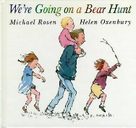  We’re Going on a Bear Hunt
A repetitive and rhythmical traditional story which adds one character to the sequence each time, supporting re-telling skills | A rhyming text with catchy refrains which encourages children to join in.  The flaps and holes make it an interactive and memorable story. | A traditional tale which encourages prediction. It follows a clear sequence with a twist at the end. It provides opportunities to discuss familiar materials and ‘forces’. | A traditional tale with a simple adventure story-line and repeated refrains.  This provides an opportunity to embed the concept of a beginning, a middle and an end to a story. | A story about growth and change with repeated phrases. Opportunities to embed concepts including the days of the week and counting as well as developing vocabulary for food. It also introduces the lifecycle of the butterfly. | The pattern and rhythm of the book invites children to join in. The story provides opportunities to play with sound and sound effects and to embed directional language.
Enormous, huge, heave, planted, budge. | Telescope, testing, yells, surprise, glad. | Peeped, squealed, bellowed, beware, scurried, crept. | Gooey, crumbly, piping hot, munching, feast. | Caterpillar, cocoon, chrysalis, nibbled, beautiful, metamorphosis | Over, under, through, narrow, swirling, stumble, oozy, gloomy.
‘Inside out’ Nursery Rhymes (in bold)
https://www.littlewandlelettersandsounds.org.uk/resources/for-parents/

Wind the Bobbin Up  See the Little Bunnies  Dingle Dangle Scarecrow | Twinkle, Twinkle  Zoom, Zoom  1,2,3,4,5, Once I caught a fish alive | The Grand Old Duke of York  Humpty Dumpty  Incy Wincy | Old Macdonald  Baa, Baa Black Sheep  Pat-a-cake, Pat-a-cake  5 Little Ducks | Mary, Mary Quite Contrary  Round the garden  Little Arabella Miller  Tiny Caterpillar on a leaf | The wheels on the bus  A Sailor went to sea, sea, sea
Perform: Harvest Festival, Christmas Concert |  |  |  | Perform: Class assembly

