 | Summer 1 | Summer 2 |  |  | Summer 1 | Summer 2
Big question | Why are tropical rainforests so important? | - Why do some species survive while others go extinct? |  | History |  | Historical ages
Visits, visitors and experiences | Aspirations week  Kew Gardens trip | Residential trip  Year 6 Show  Leavers Assembly |  | Geography | Tropical rainforests  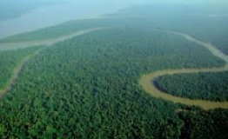
English | Rainforest tasks – comparative texts with rainforest promotion/review, dialogue piece | Whole school writing task  Completing and reviewing independent writing portfolio |  | Design and Technology |  | Electrical systems  Steady hand game  
Whole Class Reading |   Windrush child  Rainforest poetry | Reading Comprehension  Answering written questions |  | Music | Dynamics, Pitch and texture   | Year 6 Show rehearsals
Maths | Revision of place value, number, fractions and percentages and consolidation | Themed projects and problem solving |  | Art | Digital art  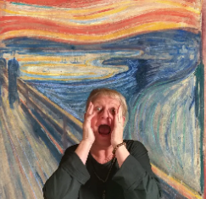 | Digital art
Science | Inheritance and evolution   | Inheritance and evolution |  | RE | Why do some people believe in God and some people not? | How does faith help when life gets hard?
Computing | iApp design | iProgram |  | PSHE | Understanding Economic wellbeing | Transitions
PE | Athletics/Tennis | Rounders |  | MfL | Planning a holiday | Visiting a French town
Year 6 Overview of Summer Term

