Year 6 Overview of Autumn Term
 | Autumn 1 | Autumn 2 |  |  | Autumn 1 | Autumn 2
Big question | How does human activity affect Richmond Park’s environment? | If you could travel back in time to an ancient Maya city at its peak, what would you see and what questions would you ask a king, a priest, and a farmer? |  | History | Remembrance   | Maya  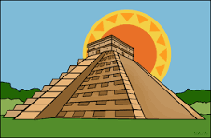
Visits, visitors and experiences | Richmond Park traffic survey | NSPCC Speak Up Stay Safe programme |  | Geography | Richmond Park  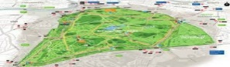 | 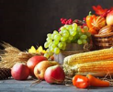  Harvest Festival
English | 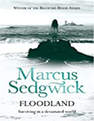 | 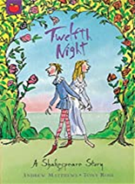 |  | Design and Technology |  | Food technology – ‘Come Dine With Me’
Whole Class Reading | 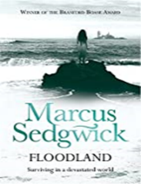 | Newspaper articles  Leaflet on Richmond Park  How the Grinch stole Christmas |  | Music | Blues/Harvest song | Film music/Christmas songs
Maths | Place value, addition, subtraction, multiplication and division | Fractions, decimals and percentages |  | Art | Drawing – making my voice heard  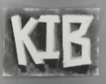    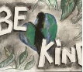  Diego Rivera & Mayan Art
Science | 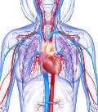  The circulatory  system | Light and Shadows |  | RE | Islam - What does it mean to be a Muslim in Britain today? | How does faith help when life gets hard?
Computing | iSafe | iProgram1 |  | PSHE | Family and relationships | Health and wellbeing
PE | NFL and Golf | Gymnastics and tag rugby |  | MfL |   French sport and the Olympics | French football champions

