 | 9.00-9.10 | 9.10-9.45 | 9.45-10.45 | 10:45 – 11:05 | 11:05-12.15 | 12.15-1.15 |  | 1.30-2.15 | Break | 2.30– 3.30
MONDAY | Register | Whole School Assembly   | Spelling and English  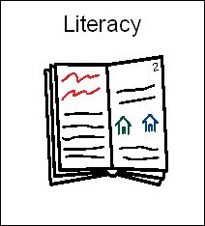 | Playtime | Maths  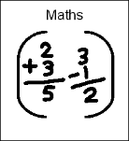 | Lunch | Register and Handwriting | History/Geography   |  | RE
TUESDAY | Register | Group Reading  | English |  | Maths |  |  | Science   |  | Library  
WEDNESDAY | Register | Group Reading | English |  | Maths |  |  | French/maths mastery/PSHE   |  | French/maths mastery/PSHE
THURSDAY | Register and Spellings | Group  Reading | PPA  (PE/MUSIC) |  | PPA  (PE/MUSIC) |  |  | Maths |  | ICT  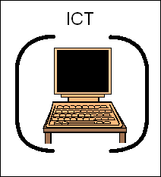
FRIDAY | Register | Group Reading | English |  | Maths |  |  | Art/DT   |  | Award Time