Year 3 Overview of Summer Term
 | Summer 1 | Summer 2 |  |  | Summer 1 | Summer 2
Big questions | Why are leaves green?  How do plants make oxygen? | How did the Romans become such a powerful empire?  What did the Romans eat and drink? |  | History | The Romans  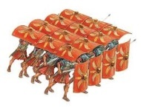 | The Romans  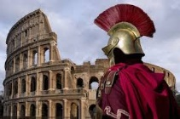
Visits, visitors and experiences | Roman Workshop  Class Assembly | Sports Day |  | Geography |  | Kingston and beyond to Italy
English | 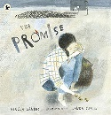  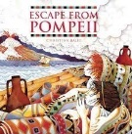 | 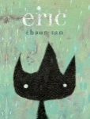  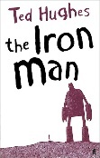 |  | Design and Technology |  | Making a seasonal recipe
Whole Class Reading | The king of football  Climate change  Sir David Attenborough | Space tourism  The girl who turned to stone  Albert Einstein |  | Music | Adapting and transposing motifs (Theme: Romans) | South Africa  (Instrumental lessons on tuned percussion)
Maths | Fractions  Money | Time  Shape  Statistics |  | Art | Drawing –  Shape and tone in drawing | Drawing –  Observational drawing skills
Science | Plants  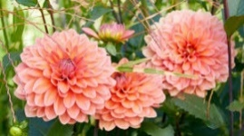 | Animals including humans |  | RE | How and why do people mark the significant events of life? | Judaism
Computing | iProgramme | iProgramme |  | PSHE | Economic wellbeing | RSE  Safety
PE | Dodgeball  Cricket | Athletics  Fundamental skills |  | MfL | French transport | A circle of life

